Afterglow Access (AgA) Software Manual

Authored by: Naleah Boys, Neal Boys, Amanda Allen, Tia Bertz,
Mike Prokosch, and Tim Spuck
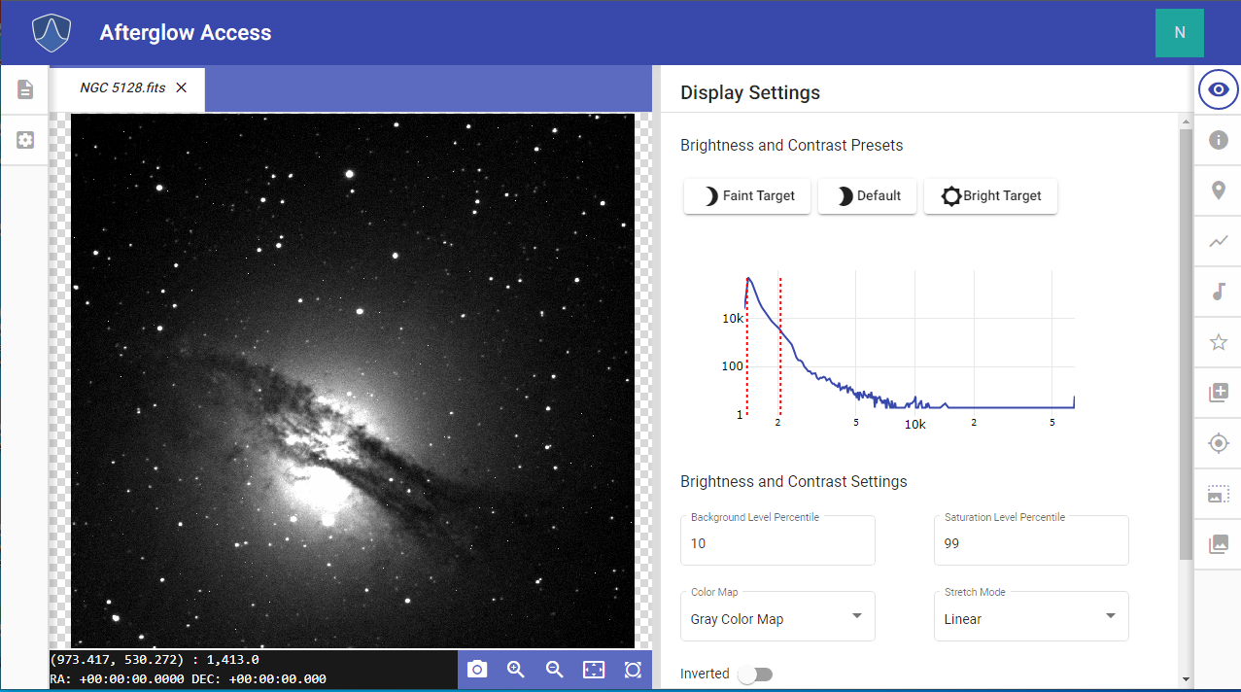

Table of Contents
- INTRODUCTION…………………………………………. …….. 1
- FILES AND THE FILE LIBRARY LIST…………..…………… 3

NAVIGATING THE AgA WINDOW…………..………………... 12
- DISPLAY SETTINGS …………..…….…………..…………….. 24

SONIFICATION…………..…….…………..……………………. 35

FILE INFO…………..…….…………..…….…………..……….. 44

CUSTOM MARKERS…………..…….…………..…….……..… 48

PLOTTER…………..…….…………..…….…………..………… 53

PHOTOMETRY…………..…….…………..…….…………..….. 62

PIXEL OPERATIONS…………..…….…………..…………….. 69

WCS CALIBRATION…………..…….…………..……………… 79

ALIGNER…………..…….…………..…….…………..……….... 83

STACKER…………..…….…………..…….…………..……….. 87

LINKS TO RESOURCES…………..…….………….…..……… 92

GOING DEEPER…………..…….…………..…….………….…. 93
    - Display Settings.…….…………..……….…….……………. 94
    - Sonification.…….…………..…….…………….….………… 99
    - Aligner.…….…………..…….………………….….…………. 104
    - Stacker .…….…………..…….………………………………. 106
    - Custom Markers.…….…………..…….……………………. 107
    - Plotter.…….…………..…….…………………………..……. 110
    - Photometry.…….…………..……………...……………..…. 114
    - Pixel Operations.…….…………..…….…………..……..… 118

GLOSSARY…………..…….…………..…….…………..……… 122
- APPENDIX…………..…….…………..…….…………..………. 125

1 Back to Table of Contents

INTRODUCTION

The Afterglow Access (AgA) software was developed by Skynet at University of North Carolina – Chapel Hill as part of the National Science Foundation (NSF) STEM+C project (NSF-1640131) Research Supporting Multisensory Engagement by BVI and Sighted Students to Advance Integrated Learning of Astronomy and Computer Science (AKA Innovators Developing Accessible Tools for Astronomy or IDATA).
AgA is a web-based astronomical data analysis software package and was developed in collaboration with blind and visually impaired (BVI) and sighted individuals, including middle and high school students, undergraduate students, astronomers, software engineers, educators, and education researchers. In developing AgA, the group took a different approach and asked, “How can we provide a BVI person with an image analysis experience similar to that of a sighted individual?”
No one looks through a telescope and sees these amazing images of galaxies (see galaxy image below) and other celestial objects. In order to produce an astronomical image, we collect light from distant objects using a telescope, and bring that light to focus on a CCD chip or other detector. These CCD chips are made up of arrays of pixels, and each pixel is a “light detector”.
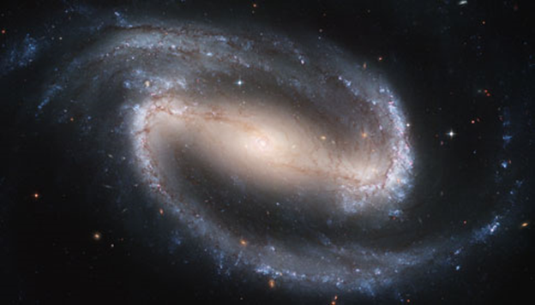
Caption: The image above shows a barred spiral galaxy in the center. The galaxy has a bar-like structure slightly tilted from the upper left to the lower right with a bright central sphere. A spiral arm comes off the right-side of the bar-like structure and wraps across the top of the bar-like structure toward the upper left of the image. Another spiral arm comes off the left side of the bar-like structure and wraps down around the bottom of the bar-like structure to the lower left of the image. The spiral arms are more blue and the bar is more orange in color.
Caption: The previous barred spiral galaxy image is composed of an array of pixels. The image above shows a highly zoomed in section of this galaxy image showing a 10 x 10 pixel section (array). The pixels in the upper right are light and they transition to black pixels in the bottom left of the image (data array).
The more light that falls on a pixel, the greater its brightness value. We then use computers to interpret these pixel values and then display the data array visually. In reality, the vast majority of the electromagnetic spectrum is invisible to the human eye. However, we choose to present the data visually, but humans are not limited to just seeing data; we could smell it, taste it, touch it, or hear it.
With AgA a user can choose to explore the data array either with sight (an image) or with sound (sonification). This AgA sonification feature provides users who are BVI the ability to experience an image or the data array through sound.
AgA also allows the user to open a variety of file formats, including fits, gif, jpg, etc. Fits files are primarily used in astronomy since the numerical value in each pixel corresponds to brightness. Other image file formats do use pixel arrays, however the value in each pixel may correspond to something other than brightness. As such, we can not accurately measure brightness of objects in image formats other than fits.
Image Captions: Please note that image captions in this software manual are intentionally more descriptive in nature. These more detailed descriptions help users who are BVI to better experience the AgA Software manual.
For comments or questions about the AgA Software Manual or accessing AgA, please visit https://idataproject.org/ and click on the Contact tab to leave a message.

2 Back to Table of Contents

FILES AND THE FILE LIBRARY LIST

To open a file, navigate to and click on the File Library List icon in the upper left-hand corner. Once this icon is selected, there should be five buttons at the top of the File Library List panel. From left to right, they are the Open Files button, the Save All Files button, the Close All Files button, the Refresh File List button, and the Select All Files button. There is also a list of all open files beneath these buttons.

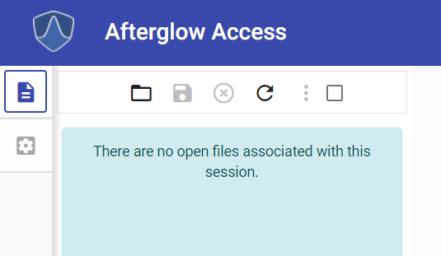
Caption: The top portion of the File Library List Panel is shown above. The Open Files button, Save All Files button, Close All Files button, Refresh File List button, and the Select All Files button is shown at the top of the image. There is also a dialogue box where the file list should be that states, “There are no open files associated with this session.”

Open Files
As the name suggests, the Open Files button opens a new file.
When this button is selected, it opens the folder directory. If the user is signed in through Google, there are two different folders present in the folder directory. The first folder is the Sample folder. The Workspace folder is located below the Sample folder.

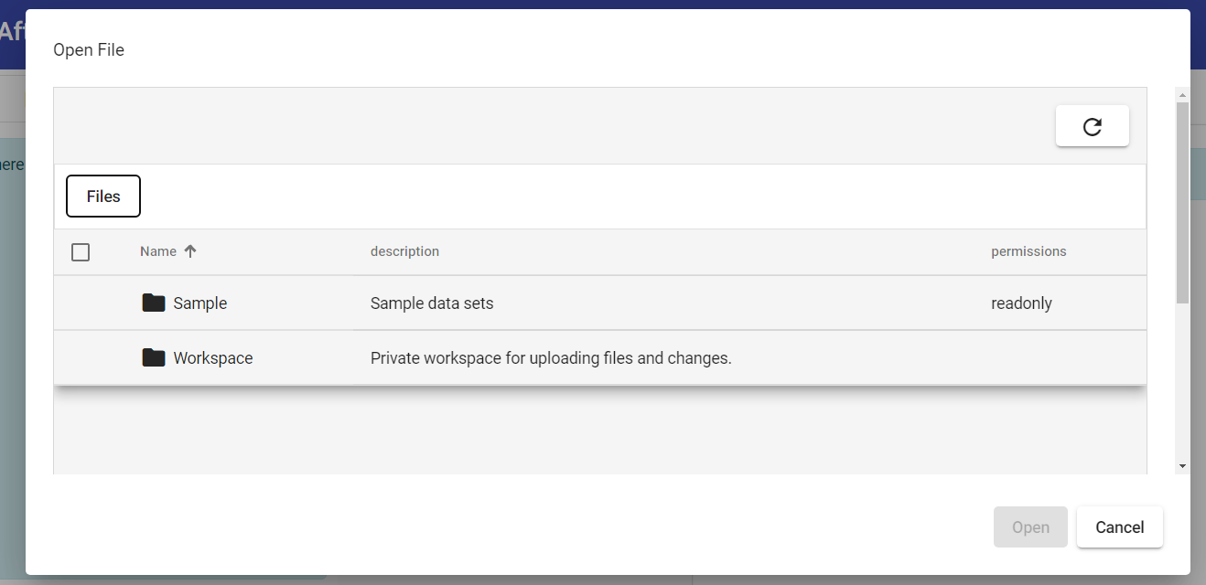
Caption: Shown above is the folder directory that is shown when the Open Files button is selected. There are two folders in this directory: Sample and Workspace. The Sample folder is listed above the Workspace folder. Additionally, there are two buttons located near the bottom right of the image. The first button is the Open button, and directly to the right of this button is the Cancel button.

Sample Folder
Different sample images are located in the Sample folder. In order to open this folder, either click on the folder and then click on the Open button (located near the bottom right of the folder directory) or double click on the folder. There are seven subfolders in the Sample folder. They are Deep Sky Objects, IDATA, Messier, Skynet Junior Scholars, Solar System, Color, and Sonification. Throughout this manual, the image NGC 5128.fits will be used as a part of the demonstrations. In order to open this file, first open the Sample folder.
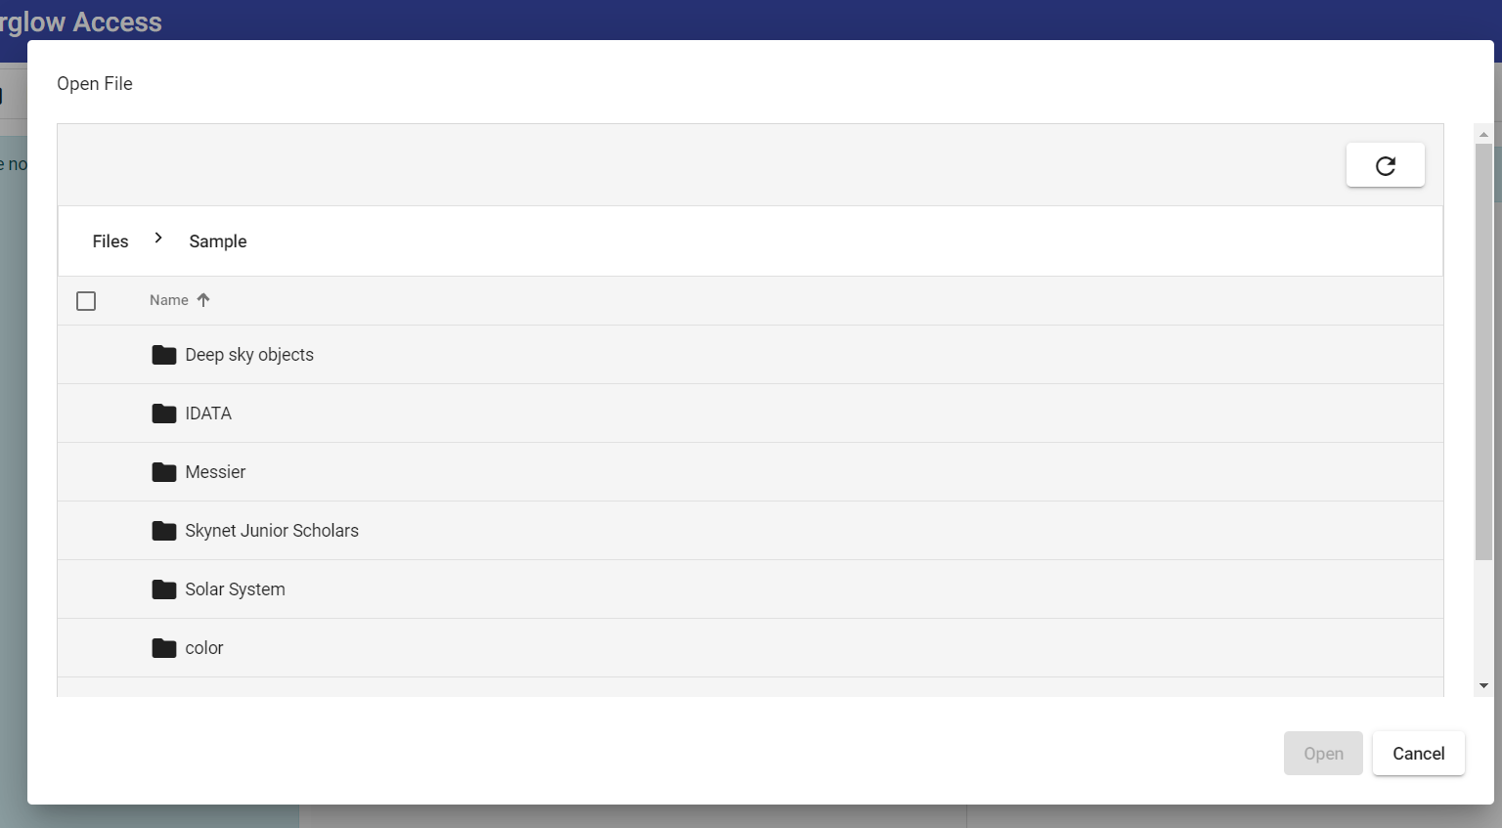
Caption: The Sample folder directory is shown above.

Next, open the Deep Sky Objects subfolder. It is the first folder listed.
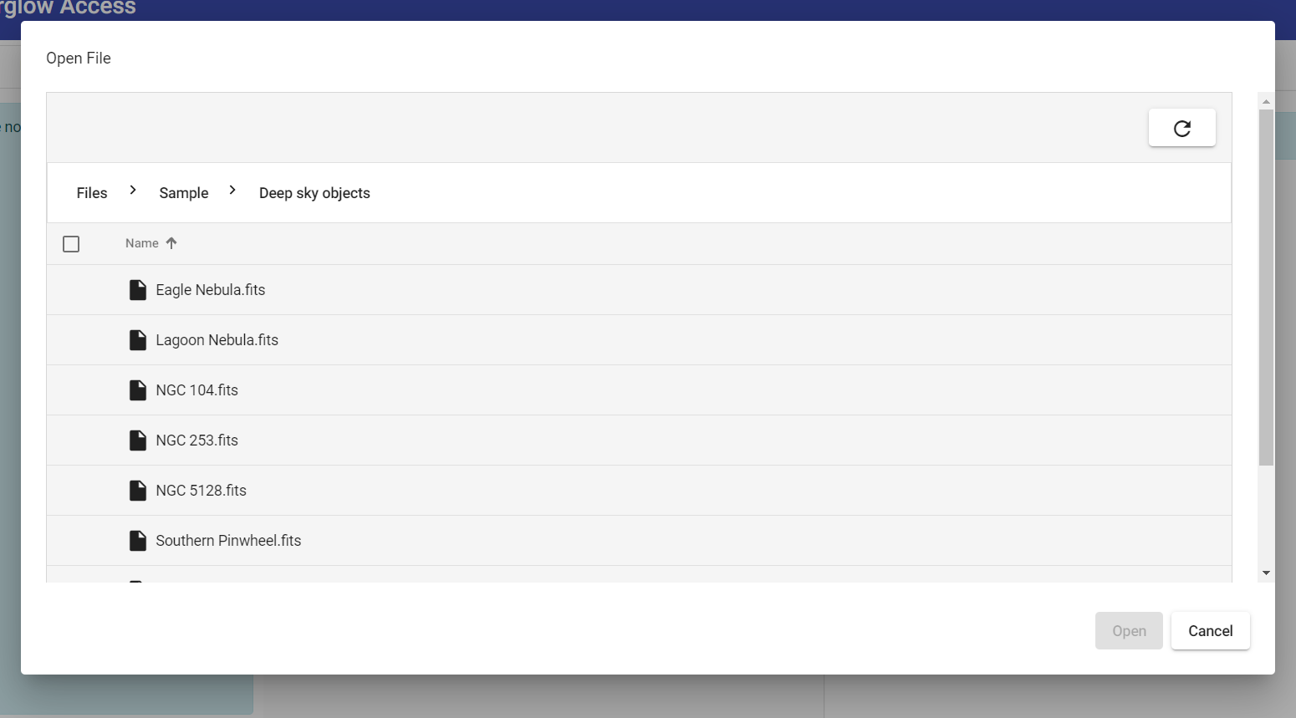
Caption: The contents of the Deep Sky Objects folder are shown above.

Finally, double-click on the NGC 5128.fits file. It is the fifth item in the Deep Sky Objects image list.
Workspace Folder
This folder allows the user to import images from their computer. In order to open this folder, either click on the folder and then click on the Open button (located near the bottom right of the folder directory) or double click on the folder.

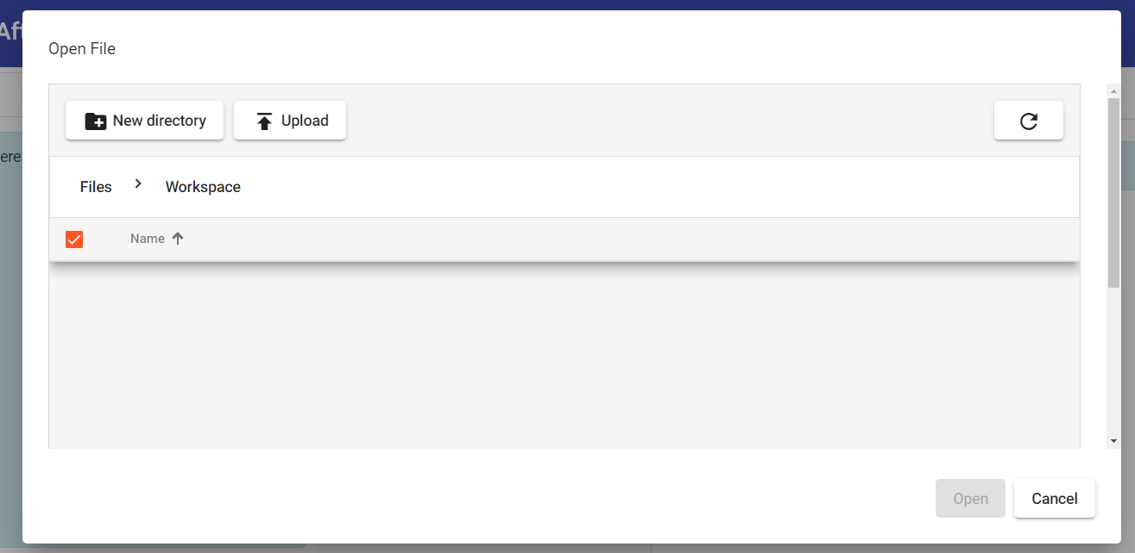
Caption: The Workspace folder is shown above with no subfolders. The New Directory button and the Upload button are located at the top left of the image. Moreover, the Upload button is located directly to the right of the New Directory button.

New Directory
The New Directory button creates a new folder directory.

Once this button is selected, a pop-up opens, and the user is able to name the new folder. Once the wanted name is entered, the user can click the Save button and the folder will appear.
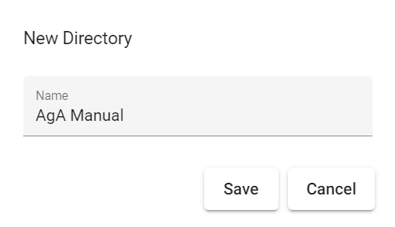
Caption: The pop-up window that opens when the New Directory button is clicked is shown above. The name “AgA Manual” is already entered into the Name box, which is located in the middle of the image. The Save button and the Cancel button are located at the bottom right. The Cancel button is located to the right of the Save button.

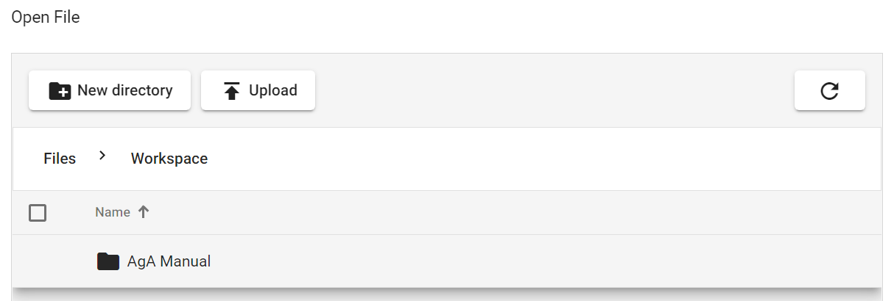
Caption: The Workspace folder once the “AgA Manual” folder from the previous image was saved is shown above.

If the user clicks on the Select All button, then several buttons appear for the user. They are Copy To, Move To, Delete, and Rename. The user is free to explore the related changes that can be made with these buttons.

Caption: This is the row of buttons that are visible once the user selects the Select All button in the Workspace folder.

Upload
The Upload button allows the user to upload their own pictures and files to Afterglow Access. Once this button is selected, it will allow the user to select and upload pictures from their own computer.
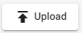

Opening a File
Once the user enters their desired folder and finds the image that they want to open, they can either double-click on the image name or click on the image name and then click the Open button, which is located near the bottom right of the folder directory pop-up window. Using the latter method, the user can open multiple images at one time. If the user accidentally clicks on an image, the user simply has to click on an image again to deselect the image. If the user wants to open all of the images in a folder, they can also click on the Select All button near the top left of the pop-up window. If it is clicked, there will be a checkmark in the box.

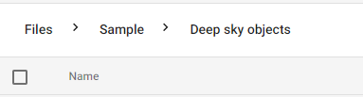
Caption: The top portion of the folder directory pop-up window is shown if the Deep Sky Objects folder is open. The Select All button is located at the bottom left of the image.
Once it is clicked, in addition to having the option of opening all of the files or folders, the user can also copy all of the files or folders to another folder in the Workspace folder. This can be achieved by clicking the Copy To button. The user could also download all of the files to their own computer. This can be achieved by clicking the Download button.

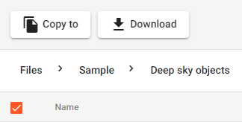
Caption: The top portion of the folder directory pop-up window is shown if the Deep Sky Objects folder is open and the Select All button is selected. The Copy To button is located at the top left of the image and the Download button is located directly to its right.

If the user ever wants to return to the previous folder or the initial file directory page, simply click on the folder name above the list of either folders or images. For example, once the user was in the Deep Sky Objects folder, they could return to the Sample folder by clicking on the word “Sample” located above the list of images.

Caption: The top portion of the folder directory pop-up window is shown if the Deep Sky Objects folder is open. The words “Files > Sample > Deep sky objects” are located at the top of the image. These words are where a user would click to return to a previous folder.

If the user wants to change the alphabetical order of the list, they simply have to click on the Name button, which is located to the right of the Select All button. The default alphabetical order is A to Z. If the Name button is pressed, then the alphabetical order will be reversed (Z to A).

If the user wants to leave the folder directory window, the user simply has to click the Cancel button, which is located at the bottom right of the folder directory pop-up window.

Save All Files
The Save All Files button allows the user to save all of the files open in their file library list to their Workspace folder, or a subfolder in their Workspace folder. Once the user selects this button, a pop-up opens that asks them whether they want to save all of the images. To save all of the images, select the Save All button, which is located near the bottom right of the pop-up window. In order to cancel this action, click the Cancel button, which is located at the bottom right of the pop-up window. Once the Save All button is selected, simply choose the wanted location in the Workspace folder. It is important to note that in order to keep all of the files that they are using, the user does not have to save the files into a folder before logging off of AgA. If the user logs in using the same method, then AgA will automatically have the same files in the user’s file library list.
Close All Files
The Close All Files button allows the user to close all of the files open in their file library list. Once the user selects this button, a pop-up opens that asks them whether they want to close all of the images. To close all of the images, select the Close All button, which is located near the bottom right of the pop-up window. In order to cancel this action, click the Cancel button, which is located at the bottom right of the pop-up window.

Refresh File List
The Refresh File List button allows the user to refresh their file list. This can be useful if a file is loading, or if the user suspects that not all of their files are being displayed.

Select All Files
The Select All Files button allows the user to select all of the files. Once this button is selected, the user can click on the three dots to the left of the button. The user will then be given three options in a pop-up list. The first is to download the selected files to the user’s computer. To perform this action, simply select the Download Selected Files button, which is located at the top of the list. The second button on the list is the Group Selected Files button. This allows the user to group the images into one composite image. Once this button is selected, the user has various options available to tweak this composite image. Many of the buttons are located to the right of each image name in the file library list. The user is free to explore these settings. If the user wishes to undo this composite image, they simply have to click on the third button in the pop-up list: Split Selected Files. As the name suggests, it will ungroup the selected images.

3 Back to Table of Contents

NAVIGATING THE AgA WINDOW

The Afterglow Access (AgA) main window is made of panels that can be shown or hidden. These panels contain all of the tools used by AgA to analyze and experience the images. There are 13 different tabs or icons that can be selected to display the different panel features of AgA.

Hiding and Unhiding a Feature Panel
Select or click on any icon to show the feature’s panel. Select or click on the same icon to hide that panel. The user can also select a different icon on the same side of the screen to switch between feature panels.
Keyboard Shortcuts
Keyboard shortcuts can be used to quickly navigate to the different tools and features of AgA. They can also be used to aid in the use of a tool. In this manual, the plus sign, “+”, is used to signify that two keys need to be pressed, not that the user needs to press the plus sign. While in some cases, the order in which the keys are pressed does not matter, sometimes the order does matter. The keyboard shortcuts will be given in quotation marks, but quotation marks do not need to be pressed. Additionally, brackets are used to give further description regarding what key should be pressed. To view a complete list of shortcuts, visit the first appendix of this manual.
What Are the Different Panels?
The top left side of the main window has 2 icons. The icon that is currently selected can be expanded by using the shortcut “,” [comma], and the user can exit the expanded view by using the shortcut “ESC” [escape].
File Library List
The first icon is the File Library List icon. Select the icon to show/hide the file library list. This icon is the top icon on the left side.

With the file library list open, the user can open a new file using the Open File button. The shortcut to use the Open File button is “shift + F”.

Global Settings
The second icon, which is positioned below the File Library List icon, is the Global Settings icon.

Focused Viewer
The Focused Viewer feature allows for multiple images to be displayed at the same time. In order to use the Focused Viewer feature, multiple picture tabs need to be opened in the display window. To open multiple pictures, have one picture selected and on display in the display window. Then, double-click on another file in the file library list. Now, above the display window, there should be two tabs. These tabs should be the names of each file.
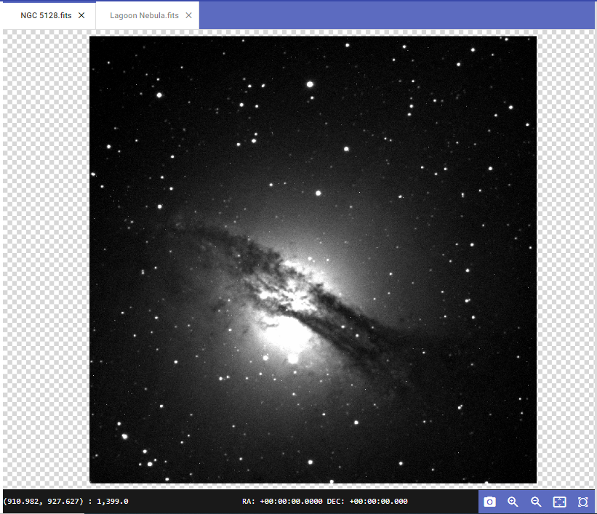
Caption: This image shows the expanded AgA display window. The central portion of the image has an image of an irregular galaxy NGC 5128. The image has a gas disk stretching from the left middle to the lower right with a brighter sphere in the middle.
Once multiple files are open, navigate to the Global Settings icon. The first option in Global Settings is the “Focused Viewer” drop-down menu. The options available in this menu are all of the files that are currently open in the display window. There are four buttons beneath this drop-down menu. These options, from top to bottom, are Split Viewer Right, Split Viewer Left, Split Viewer Down, and Split Viewer Up.
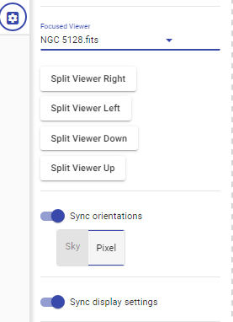
Caption: These are the different features of the Focused Viewer feature. They include the Split Viewer buttons, the “Sync Orientation” toggle button, and the “Sync Display Settings” toggle button.

When Split Viewer Right is selected, two vertical display windows are created. The image that is selected in the drop-down menu will be displayed in the right window.
When Split Viewer Left is selected, two vertical display windows are created. The image that is selected in the drop-down menu will be displayed in the left window.
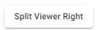
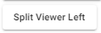
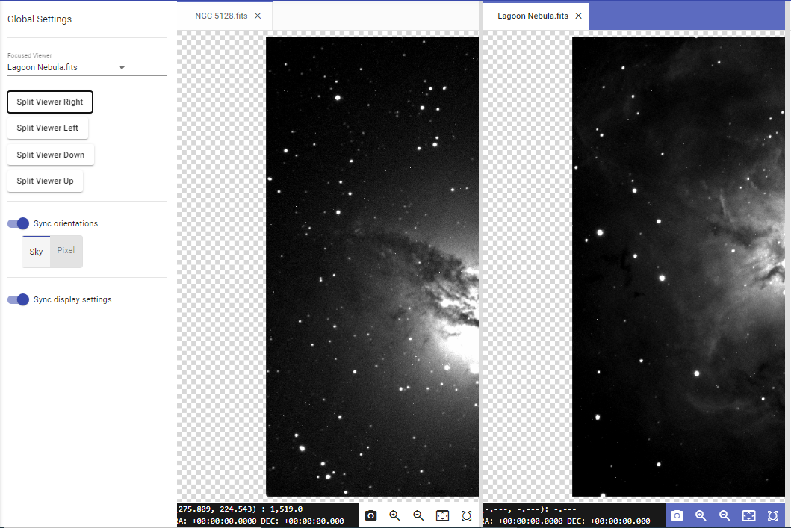
Caption: This is the AgA display window when the Split Viewer Right button is selected. On the left side of the image is the “Focused Viewer” drop-down menu. On the left-hand side of the AgA display window is a partial view of the irregular galaxy NGC 5128. The image has a gas disk stretching from the left middle to the lower right with a brighter sphere in the middle, but only half of the sphere is visible. On the right-hand side of the AgA display window is a partial view of the Lagoon nebula.

When Split Viewer Down is selected, two horizontal display windows are created. The image that is selected in the drop-down menu will be displayed in the lower window.
When Split Viewer Up is selected, two horizontal display windows are created. The image that is selected in the drop-down menu will be displayed in the upper window.

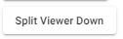
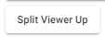
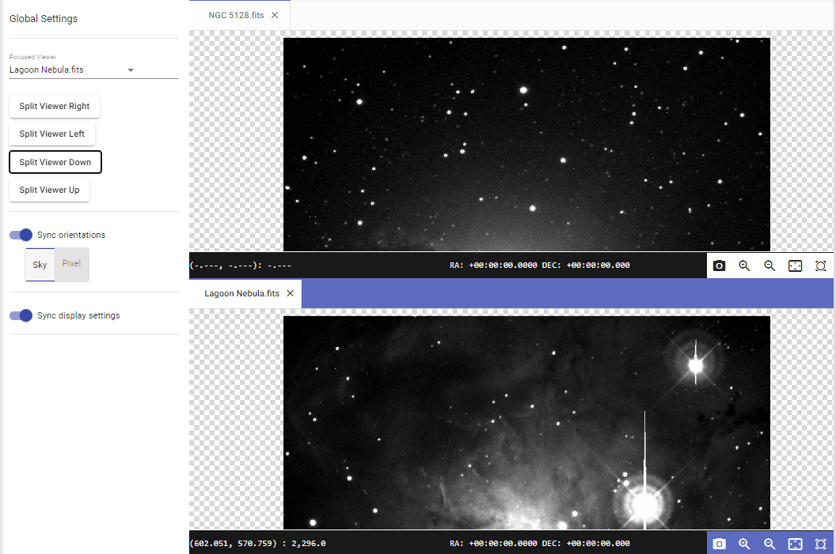
Caption: This is the AgA display window when Split Viewer Down is selected. On the left side of the image is the “Focused Viewer” drop-down menu. On the top half of the AgA display window is a partial view of the irregular galaxy NGC 5128. No discernible features are present. On the bottom half of the AgA display window is a partial view of the Lagoon nebula.

Note: To exit this mode, simply drag the file name tab in the display window to the other display window. This exits the Focused Viewer mode.

Sync Orientation
The “Sync Orientation” toggle button can sync all of the files. If the Sky button is selected, then it only matches the right ascension and declination of images in the same area of the sky (as long as they have WCS). If the Pixel button is selected, then it matches all of the pixel locations of each file. For example, if the user zooms into one picture, then it automatically zooms into all of the pictures.
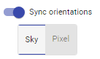
Sync Display Settings
The “Sync Display Settings” toggle button syncs the chosen options in the Display Settings tool panel to all of the files. For example, if the user chooses the Bright Target button in the Display Settings tool panel, all of the files would automatically have this preset on them.
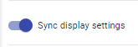

Account Profile
The Account Profile icon is located at the top right of the main window page. This icon has 3 functions.
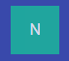
Theme Editor: Keyboard Shortcut “shift + T”
In the theme editor, the user can select the color theme (the default is indigo light, which is what is shown in all of the pictures in this manual). The user can also select the font weight and the font size.

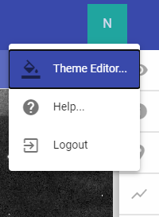
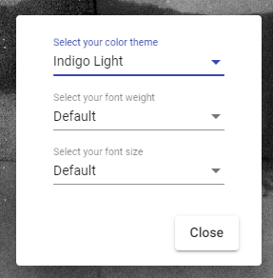

Help Tab: Keyboard Shortcut “?”
In the Help tab, the user can access information about the accessibility of AgA. The user can also access a list of all of the keyboard shortcuts. Finally, they can read more about the history of AgA.
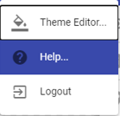
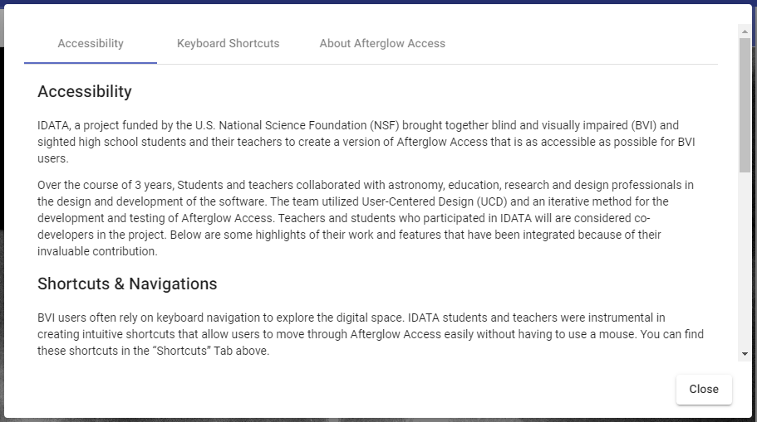
Caption: When a user first opens the Help tab, this is the first tab that is shown. This tab talks about accessibility, shortcuts and navigation, screen readers, themes, and the Sonification tool. It also has the Keyboard Shortcuts tab and the About Afterglow Access tab.

Logout
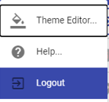
To log out of the AgA account, press the Logout button, which can be located after the user clicks on the Account Profile icon. When the user returns to AgA, all of the files will remain in the file list.

AgA Features or Tool Panels
The individual tool panels are located on the toolbar on the right-hand side of the main window. The tool panel that is currently selected can be expanded by using the shortcut “/” [forward slash], and the user can exit the expanded view by using the shortcut “ESC” [escape].
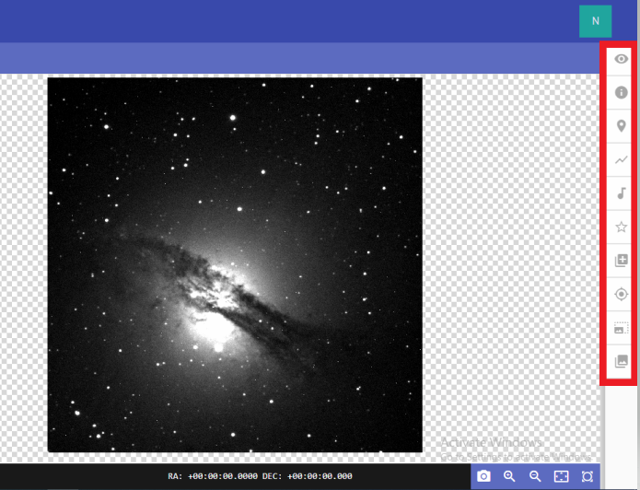
Caption: The left-hand portion of the image has an image of an irregular galaxy NGC 5128. The image has a gas disk stretching from the left middle to the lower right with a brighter sphere in the middle. The far-right side of the image has the 10 toolbar icons highlighted in a red box.
Here is a list of all of the icons in the toolbar along with their shortcuts. For more information about each tool, reference the individual sections below.

- Display Settings: The top icon on the right; shortcut “d”
- File Info: The second icon on the right; shortcut “i”

- Custom Markers: The third icon on the right; shortcut “m”
- Plotter: The fourth icon on the right; shortcut “shift + P”
- Sonification: The fifth icon on the right; shortcut “s”
- Photometry: The sixth icon on the right; shortcut “p”
- Image Calculator: The seventh icon on the right; shortcut “*” [asterisk]
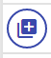
- WCS Calibration: The eighth icon on the right; shortcut “w”
- Aligner: The ninth icon on the right; shortcut “a”

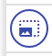

- Stacker: The bottom icon on the right; shortcut “shift + S”
Image Panel
This panel is accessible once the user has successfully opened an image. It can be expanded using the shortcut “.” [period], and the user can exit the expanded view with the shortcut “ESC” [escape].
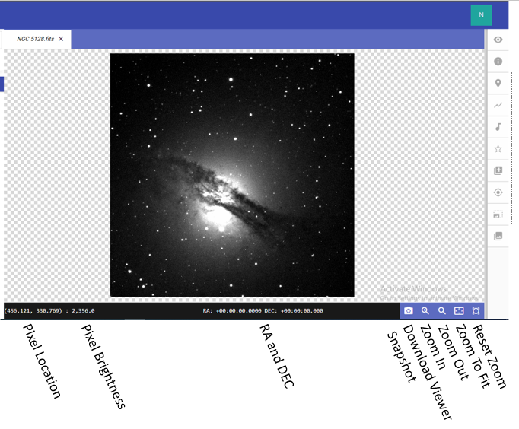
Caption: The central portion of the image has an image of an irregular galaxy NGC 5128. The image has a gas disk stretching from the left middle to the lower right with a brighter sphere in the middle. The bottom of the image has eight icons and values that are displayed on the screen labeled.
The eight icons and values along the bottom of the panel are listed below.

Pixel Location
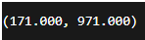
The pixel location of the user’s cursor is located on the bottom left of the image. It is in parentheses.

Pixel Brightness
The brightness of the pixel over which the user’s cursor is hovering is located on the bottom left of the panel, directly after pixel location.
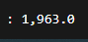
RA and DEC
The right ascension and declination of the pixel in which the user’s cursor is hovering are located on the bottom right of the panel, after the pixel brightness. It is important to note that this is only applicable if the image has been WCS calibrated before being imported to AgA or using the corresponding AgA tool.
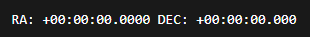
Download Viewer Snapshot
The Download Viewer Snapshot icon creates a JPEG file that shows the entire main window. It is the first icon after the RA and DEC.
Zoom In and Zoom Out
The Zoom In and Zoom Out icons change the view of the entire image by either zooming in (the magnifying glass with the plus sign) or zooming out (the magnifying glass with the minus sign). These icons are located directly to the right of the Download Viewer Snapshot icon.
Zoom To Fit
The Zoom To Fit icon automatically adjusts the image to fit in the visible portion of the image workbench panel. It is directly to the right of the Zoom Out icon.
Reset Zoom
The Reset Zoom icon resets the zoom to the previous zoom setting before the most recent changes. For example, if the user zooms in to the image, they can return to the view of the image before they zoomed in by using this icon.

4 Back to Table of Contents

DISPLAY SETTINGS
Keyboard Shortcut “d”

The Display Settings tool allows the user to change how an image is displayed in the image window. In order to access the Display Settings tool, ensure that a file is loaded into the file library list and is displayed in the image display window.

Brightness and Contrast Presets
There are three Brightness and Contrast presets. These presets are Faint Target, Default, and Bright Target.
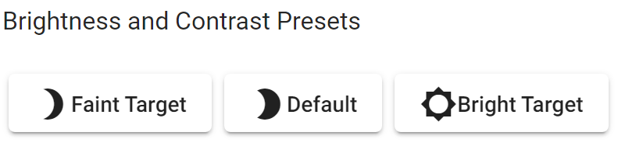
Caption: These are the Brightness and Contrast Presets. There are three buttons listed at the bottom of the image. From left to right, they are Faint Target, Default, and Bright Target.

Default
As the name suggests, the default preset is Default. Initially or when this button is clicked, the background level percentile is set at 10%, and the saturation level percentile is set at 99%. The background level percentile is related to what intensity is assigned the color black, and the saturation level percentile is related to what intensity is assigned the color white. A more in-depth discussion of background level percentile and saturation level percentile will be presented below.

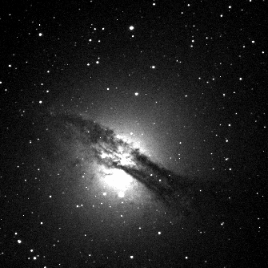
Caption: A picture of the irregular galaxy NGC 5128 using the Default preset. The image has a gas disk stretching from the left middle to the lower right with a brighter sphere in the middle.

Faint Target
As the name suggests, the Faint Target preset is for faint targets. When the Faint Target button is pressed, the background level percentile will be set at 10% and the saturation level percentile will be set at 95%.

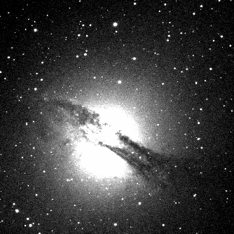
Caption: A picture of the irregular galaxy NGC 5128 using the Faint Target preset. The image has a gas disk stretching from the left middle to the lower right with a brighter sphere in the middle.

Bright Target
As the name suggests, the Bright Target preset is for bright targets. When the Bright Target button is pressed, the background level percentile will be set at 10% and the saturation level percentile will be set at 99.999%.
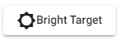

Caption: A picture of the irregular galaxy NGC 5128 using the Bright Target preset. Due to this preset, the image only contains several stars.

Brightness and Contrast Settings
These settings allow the user to change the displayed brightness, contrast, and color of the image.
Background Level Percentile, Saturation Level Percentile, and the Histogram
As stated previously, the background level percentile is related to what intensity is assigned to black. Similarly, the saturation level percentile is related to what intensity is assigned to white. The default value for the background level percentile is 10% and the default value for saturation level percentile is 99%. This means that 10% of the pixels in the image have a value below the bottom color in the color scale, and are being shown as that color. Moreover, the brightest 1% of the pixels are being displayed as the top color in the color scale. If a grayscale is being used, then 10% of pixels are being displayed as black and 1% of pixels are being displayed as white. Everything in between these intensity values is being displayed as varying shades of gray.

Caption: These are the value boxes for the background level percentile and the saturation level percentile. The value box for the Background Level Percentile is located on the left side of the image, and the value box for the Saturation Level Percentile is located on the right side of the image.

The Background Level Percentile value box allows the user to increase or decrease the background level percentile. The Saturation Level Percentile value box allows the user to increase or decrease the saturation level percentile. This allows the user to fine-tune their images. For example, increasing the background level percentile will limit the dynamic range of the pixels, however, it will also help to increase the preciseness of an image by adjusting the amount of noise that is visible. Fine-tuning the saturation level percentile will also help the user adjust the density of a color. Increasing the saturation level percentile for bright objects will help with properly displaying the image, and may provide the user with a richer color. Similarly, decreasing the saturation level percentile can help display dimmer objects, such as moons. Ultimately, by exploring these settings, the user will be able to customize the images to their own personal aesthetic style.

The histogram that is located above the Background Level Percentile value box and the Saturation Level Percentile value box can be used to help make some decisions about the proper background level percentile value and saturation level percentile value.
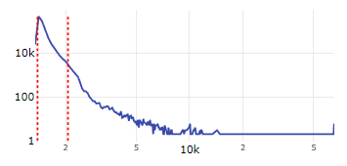
Caption: A picture of the Display Settings histogram for NGC 5128.fits. The preset used is Default. In the histogram, the x-axis represents the brightness, or intensity, of the pixel and the y-axis represents the number of pixels with that brightness.
In the histogram, the x-axis represents the brightness, or intensity, of the pixel and the y-axis represents the number of pixels with that brightness. The peak of the histogram represents the average brightness of the background of the image. Most pixels in an image are around this value, which is why there is a peak around this value. The pixels to the right of this peak have values above, or are brighter than, the background level. This is where the sources in the image are located.
Moreover, in the histogram, the red vertical dashed line on the left line represents the background level percentile. Similarly, the red vertical dashed line on the right represents the saturation level percentile. Therefore, based on the Default preset, the red vertical dashed line on the left is set at the place where 10% of the pixels are to the left of the line. Furthermore, the red vertical dashed line on the right is set at the place where only 1% of the pixels are located to the right of the line. Therefore, in the grayscale, all of the pixels to the left of the red vertical dashed line on the left are assigned the color black. In the same color scale, all of the pixels to the right of the red vertical dashed line on the right are assigned the color white. All of the pixels between these lines are assigned varying shades of gray.
There are several options available to change how the histogram is displayed. When the user hovers over the histogram, several new buttons will appear. These buttons can change whether the x- or y-axis is displayed linearly or logarithmically. They also allow the user to zoom into the graph, zoom out of the graph, or zoom the graph to fit the area.

Color Map
The “Color Map” drop-down menu allows the user to change the color map of the image. Different color maps assign different color schemes to different intensities. More specifically, it changes which color is viewed as the darkest color and which color is viewed as the lightest color. The default for this drop-down menu is the Gray Color Map. This color map assigns black as the darkest color and white as the lightest color. If the colormap is changed to the Blue Color Map, then black is the darkest color and blue is the lightest color. It is important to note that these options are not representative of the true colors of the object, and are not necessarily what the human eye would see.
If the user has images stacked (for more information on stacking, view the stacker section below), they can color map different images. For example, if someone took a picture of NGC 5128 with a blue filter, a red filter, and a green filter, they could color map each respective color to the image and then stack them. This would result in a color composite image. While adjusting the color maps, the user could also adjust other brightness and contrast settings to achieve their desired result.
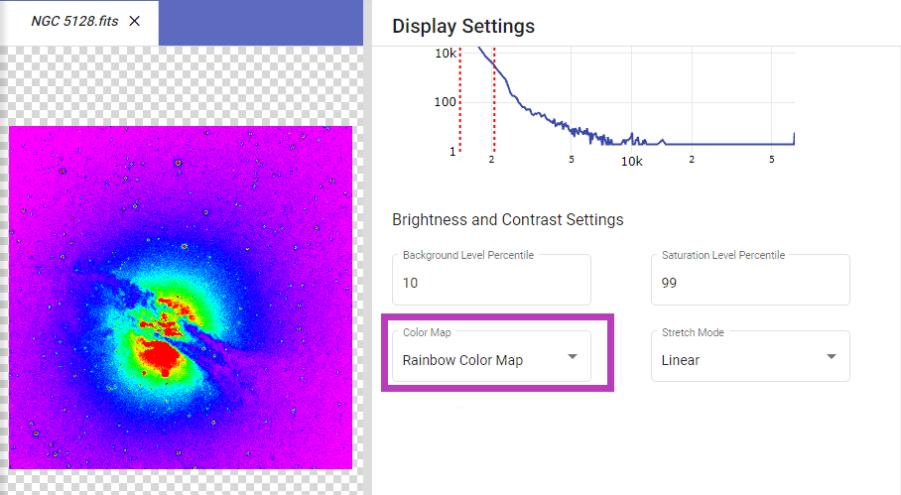
Caption: The left-hand portion of the image has an image of an irregular galaxy NGC 5128 with the Rainbow Color Map. The image has a gas disk stretching from the left middle to the lower right with a colored sphere in the middle. The top right half of the image has a histogram. The x-axis represents the brightness, or intensity of the pixel. The y-axis represents the number of pixels at a specific brightness. The bottom right half of the image showcases the Brightness and Contrast settings. The “Color Map” drop-down menu is enclosed within a purple rectangle, for further recognition.

Normalization and Stretch Mode
In order for an image to be displayed, every pixel has to be assigned a color. However, there is a finite range of values that can be assigned to a pixel. Each pixel has a red, green, and blue component. The values of each of these have to be between 0 and 255. However, the intensity of the pixels can range from 0 to over 8,000. Therefore, these intensities have to be converted into the correct range. This conversion process is called normalization. The previous subsections of this section have already explained part of the normalization process.
It was explained above that the background level percentile determines which pixels are assigned the darkest color and that the saturation level percentile determines which pixels are assigned the lightest color. Moreover, the color map determines which color is the darkest color and which color is the lightest color. It follows that stretch mode is the way in which Afterglow Access determines which pixel intensities are assigned the interim colors, or the colors between the two extremes.
In other words, the “Stretch Mode” drop-down menu allows the user to select the way in which the colormap is applied. There are four options in the drop-down menu: Linear, Logarithmic, Square Root, and Hyperbolic Arcsine. The default stretch mode is Linear.
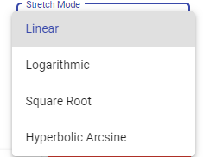

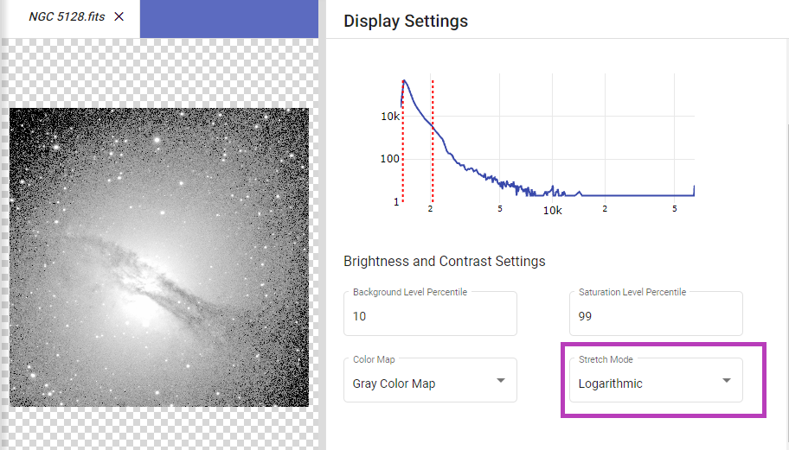
Caption: The left-hand portion of the image has an image of an irregular galaxy NGC 5128 with a Logarithmic stretch mode. The image has a gas disk stretching from the left middle to the lower right with a brighter sphere in the middle. The top right half of the image has a histogram. The x-axis represents the brightness, or intensity of the pixel. The y-axis represents the number of pixels at a specific brightness. The bottom right half of the image showcases the Brightness and Contrast settings. The “Stretch Mode” drop-down menu is enclosed within a purple rectangle, for further recognition.
Inverted Toggle Button
If the user selects the “Inverted” toggle button, the color map of the image will be inverted.
For example, if the user is using the Gray Color Map, before the inversion, black will be assigned to the pixels with the lowest intensity and white will be assigned to the pixels with the greatest intensity. If the “Inverted” toggle button is selected, white will now be assigned to the pixels with the lowest intensity and black will be assigned to the pixels with the greatest intensity.
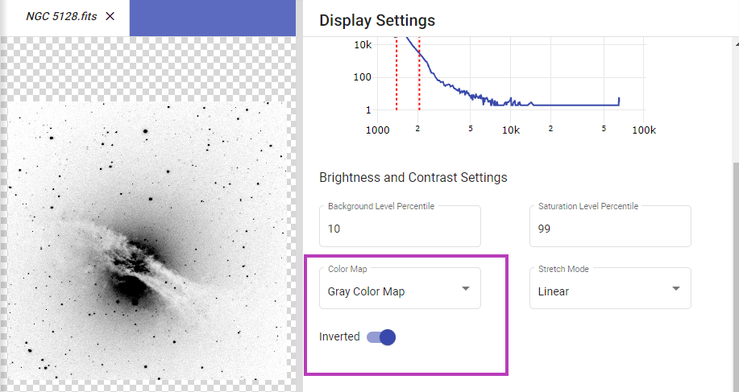
Caption: The left-hand portion of the image has an inverted image of an irregular galaxy NGC 5128 with a Gray Color Map. The image has a gas disk stretching from the left middle to the lower right with a brighter sphere in the middle. The top right half of the image has a histogram. The x-axis represents the brightness, or intensity of the pixel. The y-axis represents the number of pixels at a specific brightness. The bottom right half of the image showcases the Brightness and Contrast settings. The “Color Map” drop-down menu and the “Inverted” toggle button are enclosed within a purple rectangle, for further recognition.

Similarly, if the user is using the Red Color Map, before the inversion, black will be assigned to the pixels with the lowest intensity and red will be assigned to the pixels with the greatest intensity. If the “Inverted” toggle button is selected, red will now be assigned to the pixels with the lowest intensity and black will be assigned to the pixels with the greatest intensity.

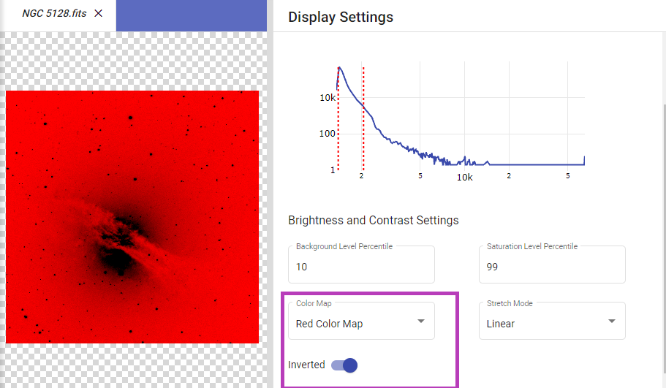
Caption: The left-hand portion of the image has an inverted image of an irregular galaxy NGC 5128 with a Red Color Map. The image has a gas disk stretching from the left middle to the lower right with a brighter sphere in the middle. The top right half of the image has a histogram. The x-axis represents the brightness, or intensity of the pixel. The y-axis represents the number of pixels at a specific brightness. The bottom right half of the image showcases the Brightness and Contrast settings. The “Color Map” drop-down menu and the “Inverted” toggle button are enclosed within a purple rectangle, for further recognition.

Image Orientation Options
The Image Orientation Options allow the user to change the orientation of the image. There are four buttons in this specific section. From left to right, they are Flip, Mirror, Rotate, and Reset Orientation. The Flip button switches the bottom part of the image to the top and the top part of the image to the bottom. The Mirror button switches the left part of the image to the right and the right part of the image to the left. The Rotate button rotates the image to the right 90°. The Reset Orientation button resets the image’s orientation to its original position.
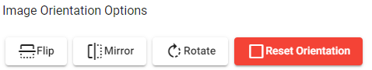

Note: An image will only sonify in its original position. See the section on the Sonification tool for more information.

5 Back to Table of Contents

SONIFICATION
Keyboard Shortcut “s”
The Sonification tool is an innovative way to translate astronomical images into informative sounds for BVI users.

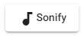
Once an image is uploaded to the viewer, the user may push the Sonify button to “hear” the image.

How it Works
To understand how the sonification tool works, it is best to imagine a piano keyboard stretched across the bottom of the image (as pictured below).
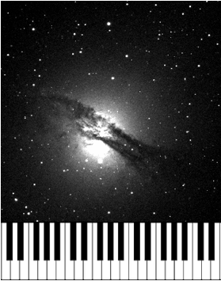
Caption: The top two-thirds of this image has an image of an irregular galaxy NGC 5128. The image has a gas disk stretching from the left middle to the lower right with a brighter sphere in the middle. Underneath NGC 5128 are 41 piano keys to symbolize how the image is sonified.
When the user clicks the Sonify button (the lowest button on the Sonification panel; image available above), this keyboard starts moving up across the image. As this keyboard moves up across the image (shown as a blue line, reference the image below), the pitch determines where the light is located (whether it be a planet, star, asteroid, etc.). If the pitch is lower, it means that it is closer to the left-hand side of the image. Conversely, if the pitch is higher, it means that the object is closer to the right-hand side of the image. There is also a starting and ending tone to signify when the sonification starts and when it ends. When the object is not a point source (like a star), white noise also plays to signify this condition. For example, the user will hear white noise if they sonify a picture of a nebula or even a globular cluster. Additionally, the loudness of a tone signifies how bright the object is. For example, if a tone that signifies a star is louder than a tone that signifies an asteroid, it means that the star is brighter than the asteroid.
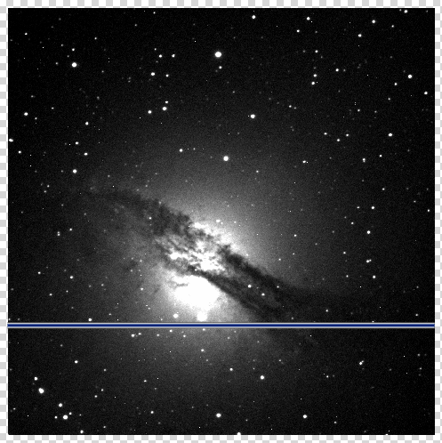
Caption: This image is an image of an irregular galaxy NGC 5128. The image has a gas disk stretching from the left middle to the lower right with a brighter sphere in the middle. There is a horizontal blue line that is located in the bottom third of the image.

Note: Flipping, rotating, and reflecting the image (as described in the Display Settings section) does not change the way in which the object is sonified.

Duration and Tones
The user can change how the Sonification tool sounds by changing the duration of the sonification and the number of tones used in the sonification.

These tools can be found in the Sonification panel below the “End Pixel” information and above the “Keep selected region in viewer” toggle button. The Duration value box is located to the left of the Tones value box. “Duration” determines how long the sonification lasts in seconds. The default duration is 10 seconds. “Tones” determines how many different tones are used in the sonification. For this option, imagine a piano keyboard that has 100 keys versus 10 keys. The default number of tones is 22 tones.
Region Mode
While flipping, rotating, and reflecting the image does not change the way in which the object is sonified, there are two options (Region Modes) to manipulate the section of the image that is sonified. These options change the amount of the picture that is sonified. The two options are found in either the Viewport button or the Custom button in the Sonification panel. Viewport is the default and that is the top button found on the right, whereas the Custom button is at the same height but to the left of the Viewport button.
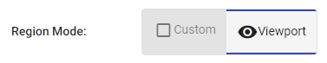
Viewport
When in the Viewport region mode for the Sonification tool, the amount of picture that is in view determines what is sonified. There are multiple ways to change what amount of the picture is in view. The first option is to zoom with the scroll bar of the mouse. The second option is to use the Zoom In, Zoom Out, Zoom To Fit, and Reset Zoom buttons as described in the “Navigating the AgA Window” section.
Custom
When in the Custom region mode for the Sonification tool, the user can change which areas of the picture are sonified based on an x- and y-axis system. The tone range is represented as the x-axis and the time range is represented as the y-axis. There are three sets of navigation buttons for each axis.

First, right beneath the Region Mode buttons are the Time Navigation buttons. From left to right, they read Early, Mid, and Late. Each of the buttons selects half of the y-axis. The Early button selects the bottom half, the Mid button selects the middle half (a quarter of the y-axis below and a quarter of the y-axis above), and the Late button selects the upper half.

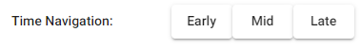
Beneath these buttons are the Tone Navigation buttons. From left to right, they read Low, Mid, and High. Each of these buttons selects half of the x-axis. The Low button selects the left half, the Mid button selects the middle half (a quarter of the x-axis to the left and a quarter of the x-axis to the right), and the High button selects the right half.
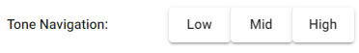

Beneath the Tone Navigation buttons are the Selection Option buttons. From left to right, they read Undo, Redo, and Reset. The Undo button undoes the previous selection that the user made. The Redo button redoes the selection that the user just undid. The Reset button undoes all of the user’s selections and makes the entire image the sonification field again.
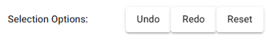

The Time Navigation and Tone Navigation buttons can be used multiple times. Once one of the buttons is chosen, the same process can be used to further narrow down the sonification field. For example, imagine that a user has identified something of interest in the middle of the image. The user used both the Mid Time Navigation and Mid Tone Navigation buttons. However, now the user hears the object of interest in the lower-left part of the image. Now, the user can use the Low Tone Navigation button and the Early Time Navigation button to further confine the sonification field.

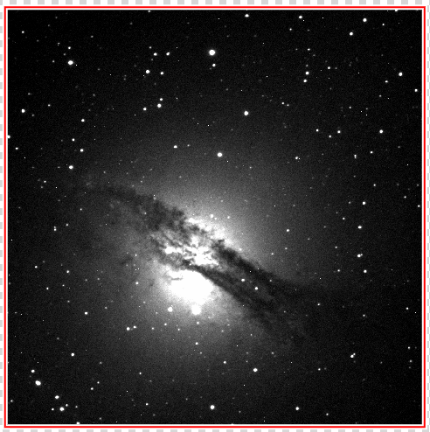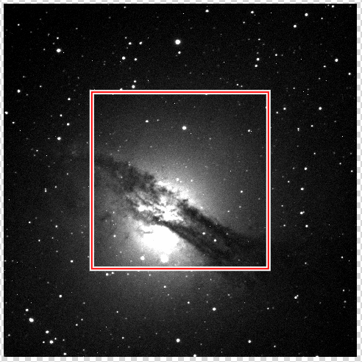

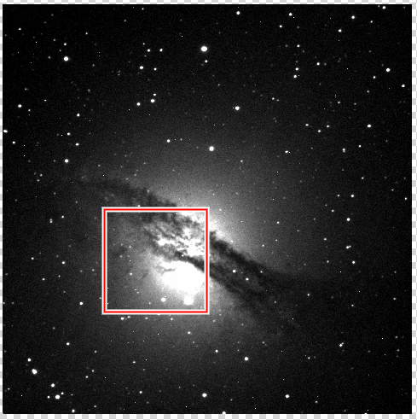
Caption: There are three pictures of an irregular galaxy NGC 5128, the first two are side by side and the third is located below the other two. The image of NGC 5128 has a gas disk stretching from the left middle to the lower right with a brighter sphere in the middle. The top left image of NGC 5128 is the full image of NGC 5128. This image also has a red square outline on the border of the image. The top right image is the full image of NGC 5128, but the red square outline is in the middle of the image. The bottom image is the full image of NGC 5128, but the red square outline is located on the image such that the bright sphere takes up the majority of the space in the red square outline.

Note: There are keyboard shortcuts, found in the Keyboard Shortcuts subsection of the Sonification section, that can be used to navigate the Custom region mode buttons. For example, there are shortcuts that negate the need to use the different Time and Tone Navigation buttons.

Note: The section of the image that is sonified in this region mode is outlined in red.

Keep Selected Region in Viewer Toggle Button
Above the Sonify button and below the Duration and Tones value boxes is the “Keep selected region in viewer” toggle button. This button appears for both the Custom and Viewport region modes, but only pertains to the Custom region mode. The default for this button is on. When it is on, as the user uses the buttons or the keyboard shortcuts to zoom into specific sections of the image, that section is automatically zoomed to fit. Otherwise, if the “Keep selected region in viewer” toggle button is toggled off, the entire image stays in view and the sonification section can be compared to the entire image. The comparison below shows the difference between when it is on and when it is off.

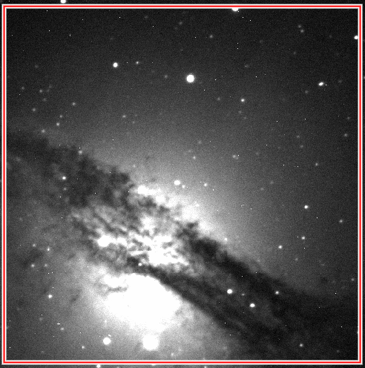 vs.
Caption: There are two pictures of an irregular galaxy NGC 5128 side by side. The image of NGC 5128 has a gas disk stretching from the left middle to the lower right with a brighter sphere in the middle. The left image of NGC 5128 is zoomed in so that the center sphere and gas disk occupies the majority of the image. This image also has a red square outline on the border of the image. The right image is the full image of NGC 5128, but the red square outline is in the middle of the image. In both images, the red square outline encompasses the same portion of the entire NGC 5128 image.
Region Size
For both region modes, like Duration and Tones, three values are always showcased. The first, either below Region Mode (for Viewport) or below Selection Options (for Custom), is the Region Size. This value describes the size of the sonification field.
Below the Region Size is the Start Pixel. In the entire pixel grid of the image, it is the specific bottom-left pixel that is first sonified. This value is given as a coordinate pair.
Below the Start Pixel is the End Pixel. Similar to the Start Pixel, in the entire pixel grid of the image, the End Pixel is the specific top-right pixel that is last sonified. Its value is also given as a coordinate pair.
For example, imagine that a user has a 1024-pixel by 1024-pixel image. If the user hears something in the upper-left corner of the image and navigates to that section using the Low Tone Navigation button and Late Time Navigation button, the Region Size would be 512 x 512 pixels. The Start Pixel would be (0.5, 512.5), and the End Pixel would be (512.5, 1024.5).

Keyboard Shortcuts
- s – open sonification
- space – play sonification
- ctrl + z – undo region change
- ctrl + y – redo region change
- ← [left arrow] – navigation: low frequency
- → [right arrow] – navigation: high frequency
- ← + → [left arrow + right arrow] – navigation: mid-frequency
- ↓ [down arrow] – navigation: early
- ↑ [up arrow] – navigation: late
- ↓ + ↑ [down arrow + up arrow] – navigation: middle
- 1 – navigation: low frequency | beginning
- 2 – navigation: mid-frequency | beginning
- 3 – navigation: high frequency | beginning
- 4 – navigation: low frequency | middle
- 5 – navigation: mid-frequency | middle
- 6 – navigation: high frequency | middle
- 7 – navigation: low frequency | end
- 8 – navigation: mid-frequency | end
- 9 – navigation: high frequency | end
- 0 – reset sonification region
In the above keyboard shortcuts, when “navigation” is mentioned in the description, it means that the shortcut is related to navigating to different sections of the image. These are also only applicable when the user is in the Custom region mode. Additionally, brackets are used to give further description regarding what key should be pressed.
Note: The plus sign, “+”, is used to signify that two keys need to be pressed, not that the user needs to press the plus sign. While in some cases, the order in which the keys are pressed does not matter, sometimes the order does matter. For example, to navigate to the mid-frequency section of the image, the user needs to press the left arrow and the right arrow at nearly the same time. However, they could press the right arrow slightly before the left arrow, and vice versa. However, to undo the previous region change, they have to click the control key before they click z.
For the keyboard shortcuts 1-9, based on the given parameters, it zooms into the corresponding section. In other words, it makes another square that uses parameters for both axes. This is different from left, right, up, down, left + right, and up + down because these shortcuts only have a parameter for one axis at a time. For example, if the user wanted to hear the beginning part (time-wise) of the image only in the high-frequency range, they would use the shortcut “3” to zoom into this specific section. This would be instead of having to press “right” and then “down.”
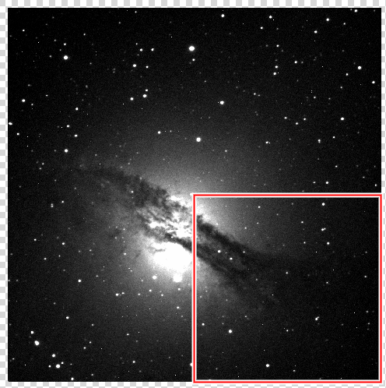
Caption: This image is an image of an irregular galaxy NGC 5128. There are two pictures of an irregular galaxy NGC 5128 side by side. This image of NGC 5128 has a gas disk stretching from the left middle to the lower right with a brighter sphere in the middle. On the bottom right quarter of the image, there is a red square outline.

A helpful trick: Imagine that the image is separated into a 3x3 grid, much like a number pad (usually on the right-hand side of a computer keyboard). Each number corresponds to the same section. For example, if the user wanted to select the upper left corner of an image, they would press “7”. It is important to note, however, that using one of these keys still sonifies a quarter of the selected region. Thus, use the number pad or 3x3 grid to only understand the position of the corresponding region, not its size.
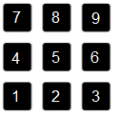

6 Back to Table of Contents

FILE INFO
Keyboard Shortcut “i”
The File Info tool allows the user to find basic information about their data files.

This information is taken from the telescope and can contain information that an astronomer would need to know when working with a dataset.
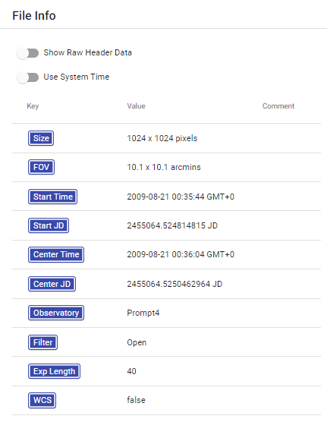
Caption: These are the different features in the File Info tool. These values are for NGC 5128. They include Size, FOV, Start Time, Start JD, and others. For a full list, read below.

Size: This refers to the size of the image or data array. It is measured in pixels.
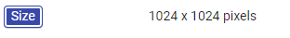
FOV: This stands for Field of View. Field of view is the amount of sky visible to the telescope’s sensor. The focal length of the telescope and the size of the sensor used to gather the data are the key factors that are related to FOV.
Start Time: This is the time when the image’s data was starting to be collected. It is measured in the standard time format, and it is listed as year, month, day, hour, minute, second, and time zone. It automatically lists this information in relation to the Greenwich Mean Time or GMT time zone.
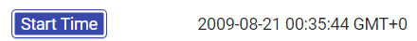

If the user selects the “Use System Time” toggle button, the time zones shown will adjust to the time zone of the user’s current computer system.

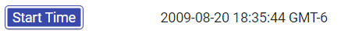
JD Start Time: This refers to the start time expressed as a Julian date. Mostly used by astronomers, the Julian date is a unit count of 1 per day starting with January 1, 4731 B.C. For example, the date August 20, 2009 at noon Greenwich Mean Time (GMT) would be shown as JD 2455064.0.
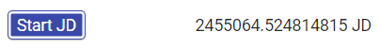
Center Time: This is the time when the image is halfway through its exposure. It is measured in the standard time format, and it is listed as year, month, day, hour, minute, second, and time zone. As stated previously, it automatically lists this information in relation to the Greenwich Mean Time or GMT time zone.
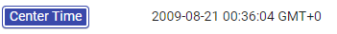
Center Julian Time: This refers to the time when the image is halfway through its exposure. It is expressed as a Julian date.
Observatory: This is the name of the observatory from which the observation was made.
Telescope: This is the name of the telescope used to make the observation. In other words, the telescope that took the image. No image of this file information can be given because it was not listed in the file information for NGC 5128.fits.

Filter: This shows which filter was used on the telescope, if any, at the time when the data was captured.
Exposure Length: This is how long the shutter was open on the camera when the data was captured.
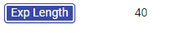
WCS: This refers to whether or not the system has WCS calibration. WCS stands for World Coordinate System. This system maps the pixels in the data to the right ascension and declination coordinates in the night sky. If WCS is listed as true, then the user can figure out the RA and DEC of any pixel in the image/data array.

Show Raw Header Data Toggle Button
There is a “Show Raw Header Data” toggle button at the top of the File Info tool panel. The default for this toggle button is off. If this toggle button is toggled on, then other information about the image is displayed. However, this information was deemed by the developers of AgA to not be as vital or commonly accessed. The user is free to explore this information, but for the purposes of this manual, it will not be discussed.
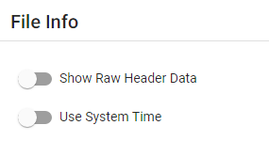
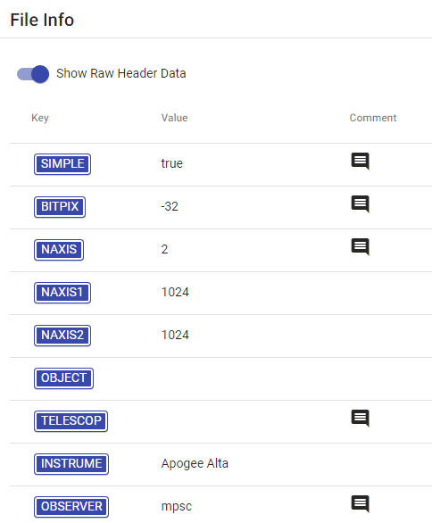

7 Back to Table of Contents

CUSTOM MARKERS
Keyboard Shortcut “m”

The Custom Markers tool is an AgA tool that allows users to add markers or labels to an image.
Add a Marker
In order to add a marker, the user simply clicks on the spot of the image in which they would like to add a marker.
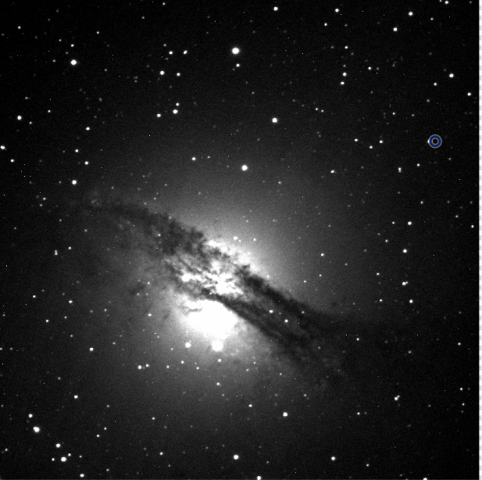
Caption: This is an image of an irregular galaxy NGC 5128. The image has a gas disk stretching from the left middle to the lower right with a darker sphere in the middle. There is a small, blue circle outline located at the top right of the image. This indicates the marker that was added. It is not centered on a nearby star.
Centroid Clicks
If the “Centroid clicks” toggle button is toggled on, when the user clicks on a star, it will shift the selected starting point towards the point of the peak value.
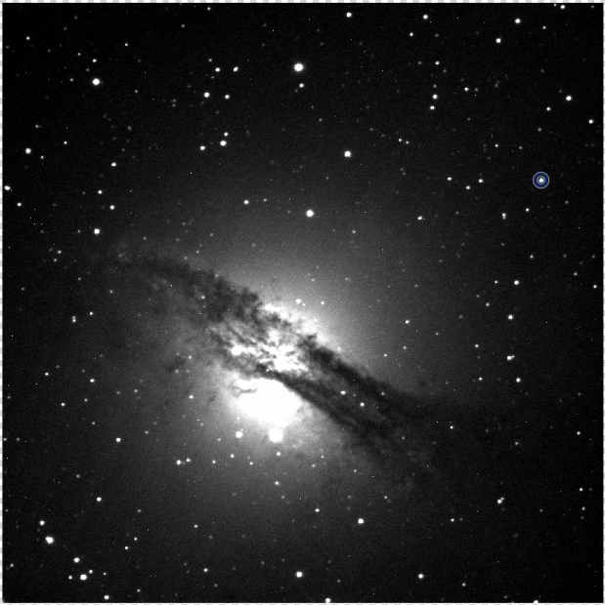

Caption: This is an image of an irregular galaxy NGC 5128. The image has a gas disk stretching from the left middle to the lower right with a darker sphere in the middle. There is a small, blue circle outline located at the top right of the image. This indicates the marker that was added. It is centered on a star.

Planet Centroiding
When the “Centroid Clicks” toggle button is toggled on, the user also has the option to toggle on the “Planet Centroiding” toggle button. If this option is selected, the software will center the starting point on the center of a planet rather than the point of the peak value. This option uses a slightly different algorithm since planets are disks of light rather than point sources, which makes the first centroiding option not as accurate.

Marker Customization
Once a marker has been added, click on the marker to open the Marker Customization settings. The marker will turn orange once it is selected. If the user wishes to place another marker below the existing marker and not open the Marker Customization settings, press and hold the alt button before clicking below the marker.

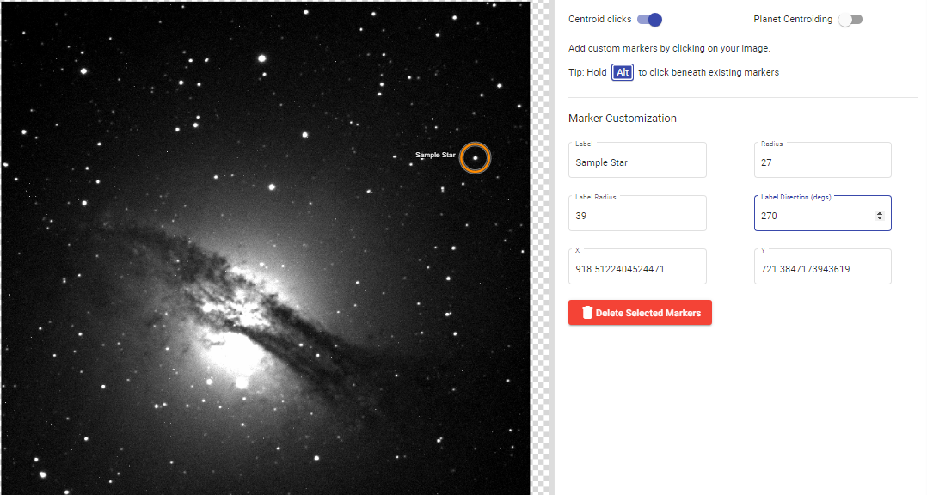
Caption: The left half of this image has an image of an irregular galaxy NGC 5128. NGC 5128 has a gas disk stretching from the left middle to the lower right with a brighter sphere in the middle. The right half of this image shows the Custom Markers tool panel, which indicates the customization options. For more information on all of the features, read below.

Label
The Label box allows the user to label or name the marker that is selected. For example, in the image above, the marker is labeled Sample Star.

Radius
The Radius value box allows the user to change the radius of the custom marker circle. This is measured in pixels.

Label Radius
The Label Radius value box allows the user to change the radius between the label and the center of the customs marker circle.
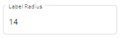

Label Direction (degs)
The Label Direction value box allows the user to change the position of the label relative to the center of the custom marker. It is measured in degrees and clockwise from the top of the custom marker circle. For example, 0° is located at the top of the circle, 90° is located at the right of the circle, and 180° is located at the bottom of the circle.
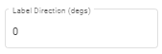

X and Y (Position)
The X and Y value boxes allow the user to change the position of the center of the custom marker. The positions are the pixel positions of the image.

Delete Selected Markers
The Delete Selected Markers button allows the user to delete the selected marker.
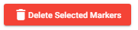

Note: When trying to select a marker, click on the center of the marker not the edge of the marker. Also, the user can put multiple markers on the same image, even in similar locations.

8 Back to Table of Contents

PLOTTER
Keyboard Shortcut “shift + P”

The Plotter tool allows the user to select a cross-section on the image or create a heat map for a selected region of the image.
1D Cross Section
This feature allows the user to select a cross-section of any region of the image. The cross-section will then graphically display the intensity of light along the selected line.
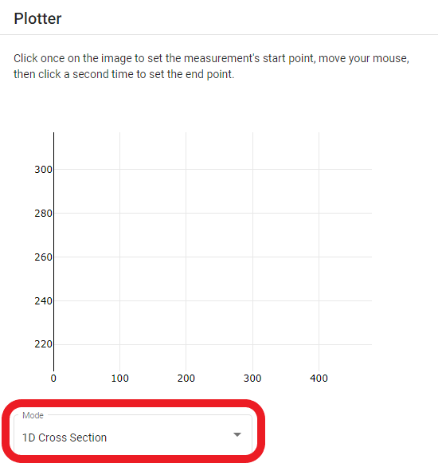
Caption: When the Plotter tool panel is initially opened, this is the 1D Cross-Section graph without any data. It is an x-y plot. The x-axis represents the pixel location along the selected line, and the y-axis represents the brightness (intensity) of the pixel.
To add a cross-section, click on the desired starting point on the image and then click on the desired ending point
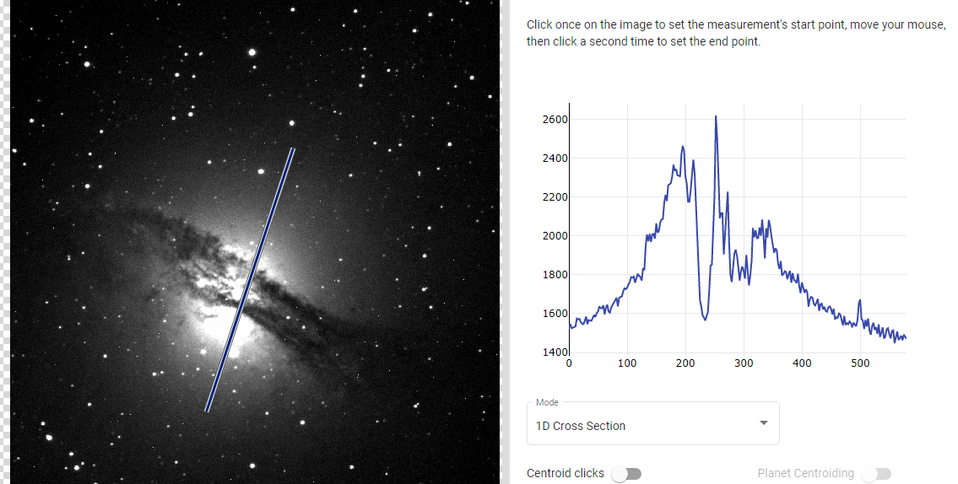
Caption: The left-hand portion of the image has an image of an irregular galaxy NGC 5128. The image has a gas disk stretching from the left middle to the lower right with a brighter sphere in the middle. The right half of the image has an x-y plot. The x-axis represents the pixel location along the selected line, and the y-axis represents the brightness (intensity) of the pixel.

The x-axis of the above x-y plot is the pixel location along the selected line and the y-axis is the intensity at the location. In other words, the x-axis represents the position along the selected line.
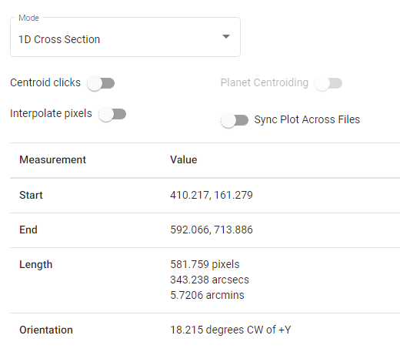
Caption: When 1D Cross Section is selected in the “Mode” drop-down menu, these are the different features and values present in the Plotter tool panel. These values are for NGC 5128. These values are for the selected cross-section. For more information on the features and values, read below.

Centroid Clicks
If the “Centroid clicks” toggle button is toggled on, when the user clicks on a star, it will shift the selected starting point towards the point of the peak value.

Planet Centroiding
When the “Centroid clicks” toggle button is toggled on, the user also has the option to toggle on the “Planet Centroiding” toggle button. If this option is selected, the software will center the starting point on the center of a planet rather than the point of the peak value. This option uses a slightly different algorithm since planets are disks of light rather than point sources, which makes the first centroiding option not as accurate.
Interpolate Pixels
If the “Interpolate Pixels” toggle button is toggled on, then the graph of the cross-section will be smoothed out. It does not have any effect on the actual points that are selected.
Sync Plot Across Files
If the “Sync Plot Across Files” toggle button is toggled on, then the same cross-section will be automatically placed on a new file.

Measurement
Here are the descriptions of all of the terms listed in the measurement table.
- Start: The starting pixel of the cross-section, in relation to the entire image. It is important to note that pixel (0,0) is considered to be the bottom leftmost pixel in the image.
- End: The ending pixel of the cross-section, in relation to the entire image.
- Length: The distance between the start pixel and the end pixel given in pixels, arcsecs, and arcmins. (Note: Similar to how 60 seconds equals 1 minute, 60 arcseconds equals 1 arcminute.)
- Orientation: The degrees clockwise (CW) of the positive y-axis (+Y) or top of the image from the starting point to endpoint. For example, a line that goes straight up would have an orientation of 0 degrees CW of +Y, a line that goes horizontal to the right (an arrow would be pointing to the right) would have an orientation of 90 degrees CW of +Y, a line that goes straight down would have an orientation of 180 degrees CW of +Y, and a line that goes horizontal to the left would have an orientation of 270 degrees CW of +Y.

2D Heat Map
This feature allows the user to select an area or region of the image. The heat map will then display the intensity of light in the area or region by assigning different colors to different intensities. There is a temperature scale on the right-hand side of the heat map.
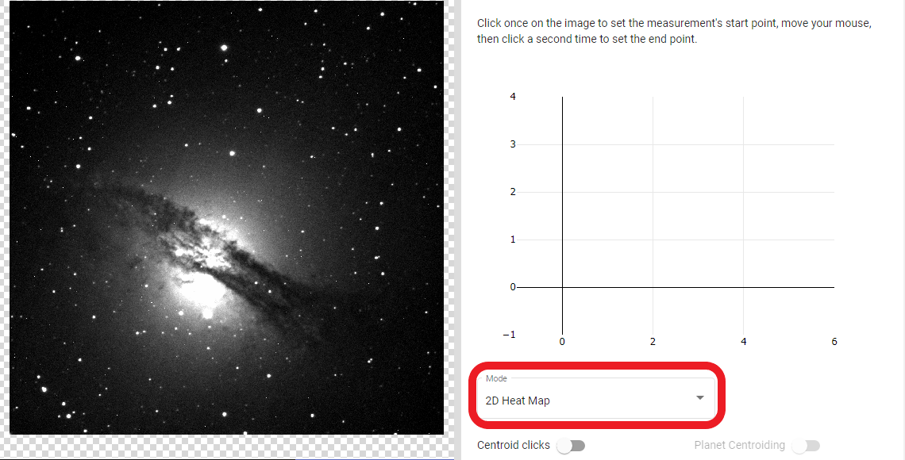
Caption: The left-hand portion of the image has an image of an irregular galaxy NGC 5128. The image has a gas disk stretching from the left middle to the lower right with a brighter sphere in the middle. The right half of the image has an x-y plot. The x-axis represents the pixel location along the selected line, and the y-axis represents the brightness (intensity) of the pixel. It also has the “Mode” drop-down menu in a red box. The x-axis and y-axis of the heat map are the horizontal and vertical pixel locations in the selected area.
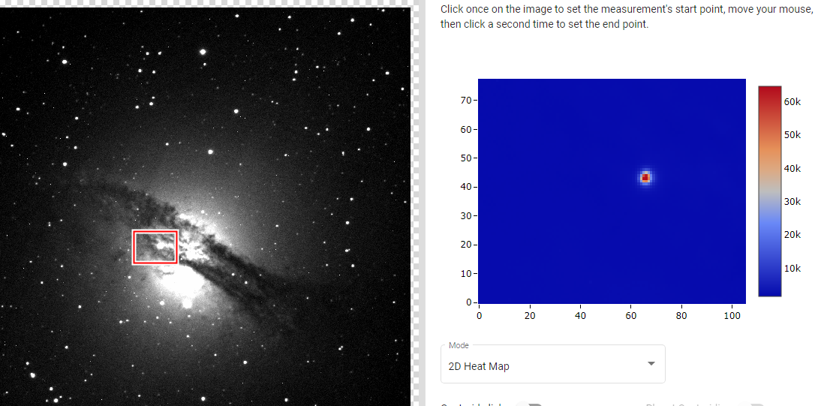

Caption: The left-hand portion of the image has an image of an irregular galaxy NGC 5128. The image has a gas disk stretching from the left middle to the lower right with a brighter sphere in the middle. The right half of the image has a 2D Heat map showing a red spot in a blue background. There is also a bar to the right of the heatmap. It starts at blue on the bottom and then shifts to yellow, orange, and red as the height in the bar increases. This indicates the intensity level.
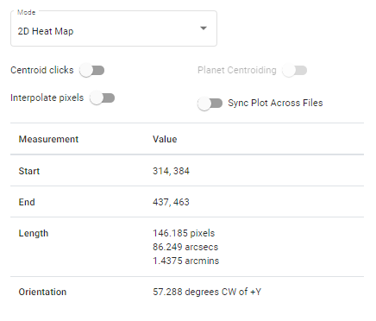
Caption: When 2D Heat Map is selected in the “Mode” drop-down menu, these are the different features and values present in the Plotter tool panel. These values are for NGC 5128. These values are for the heat map. The different toggle button functions were addressed in the 1D Cross Section section, but for more information on the given values, read below.

Measurement
- Start: The first pixel that the user clicks.
- End: The last pixel that the user clicks.
- Length: The distance between the start pixel and the end pixel given in pixels, arcseconds, and arcminutes.
- Orientation: The degrees clockwise (CW) of the positive y-axis (+Y), which is determined by the starting pixel to the end pixel.
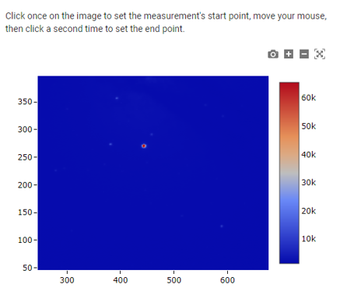
Caption: The image has a 2D Heat Map showing a red spot in a blue background. There is also a bar to the right of the heatmap. It starts at blue on the bottom and then shifts to yellow, orange, and red as the height in the bar increases. This indicates the intensity level.

Zooming Features
There are four buttons that control the user’s view of the heat map. These icons are located to the top right of the heat map.
First, there is the Download plot as a png button. This button allows the user to take a screenshot of the heat map.
Second, there is the Zoom In button that zooms into the heat map.

Third, there is the Zoom Out button that zooms out of the heat map.
Fourth, there is the Autoscale button. If this button is selected, the zoom of the heat map will resize to its original size.

Note: Flipping, rotating, and mirroring the object does not change the orientation in which the heatmap is displayed.

9 Back to Table of Contents

PHOTOMETRY
Keyboard Shortcut “p”

The Photometry tool allows the user to determine the apparent magnitude of a light source in an image.

First, the user should open the image they wish to work with. This section utilizes the file NGC 5128.fits and some of the Kleopatra images.
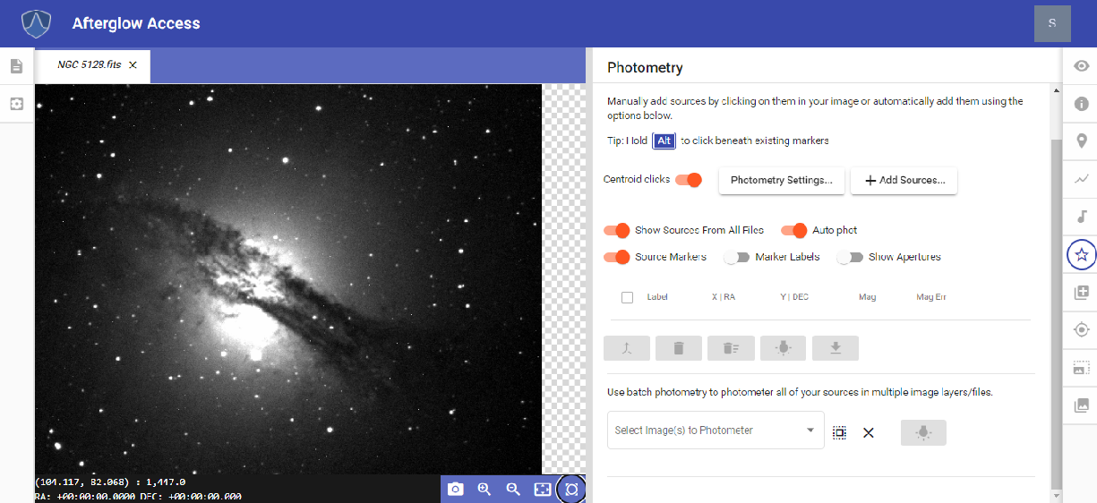
Caption: The left-hand portion of the image has an image of an irregular galaxy NGC 5128. The image has a gas disk stretching from the left middle to the lower right with a brighter sphere in the middle. The right half of the image has the upper portion of the Photometry tool panel.
If the “Centroid clicks” toggle button is toggled on, which is the default, when the user clicks on a star, it will shift the selected starting point towards the point of the peak value.
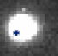

If the “Show Sources From All Files” toggle button is toggled on, which is the default, the user will see all previous points the user has clicked on within a set of open images.
If the “Auto-phot” toggle button is toggled on, which is the default, AgA will automatically measure the brightness of a star or point selected on an image. In the example given, the star’s magnitude is estimated at 9.12 with an error of 0.001.

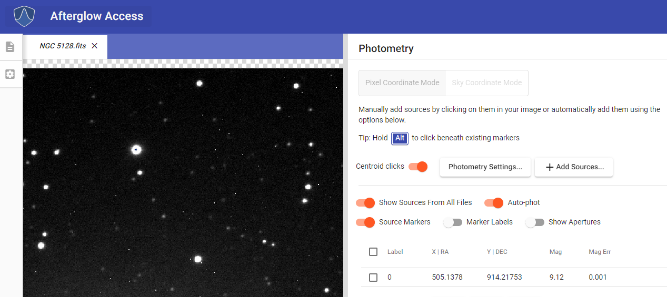
Caption: The left-hand portion of the image has an image of an irregular galaxy NGC 5128. The image is zoomed in to the top middle portion of the entire image of the galaxy. Therefore, there are no discernible features, except several stars. One of the stars that is located near the upper left-hand corner has a small blue dot on its center. The right half of the image shows the upper portion of the Photometry tool panel. One source is shown in the Photometry list. The source is the star that has the blue dot on it.
If the “Source Markers” toggle button is toggled on, which is the default, two other toggle buttons become available: “Marker Labels” and “Show Apertures”.
If the “Marker Labels” toggle button is toggled on, which is not the default, then each point or star the user has selected will be assigned a sequential number in the order they have been selected. The first one will be labeled 0, the second one will be labeled 1, and so on.
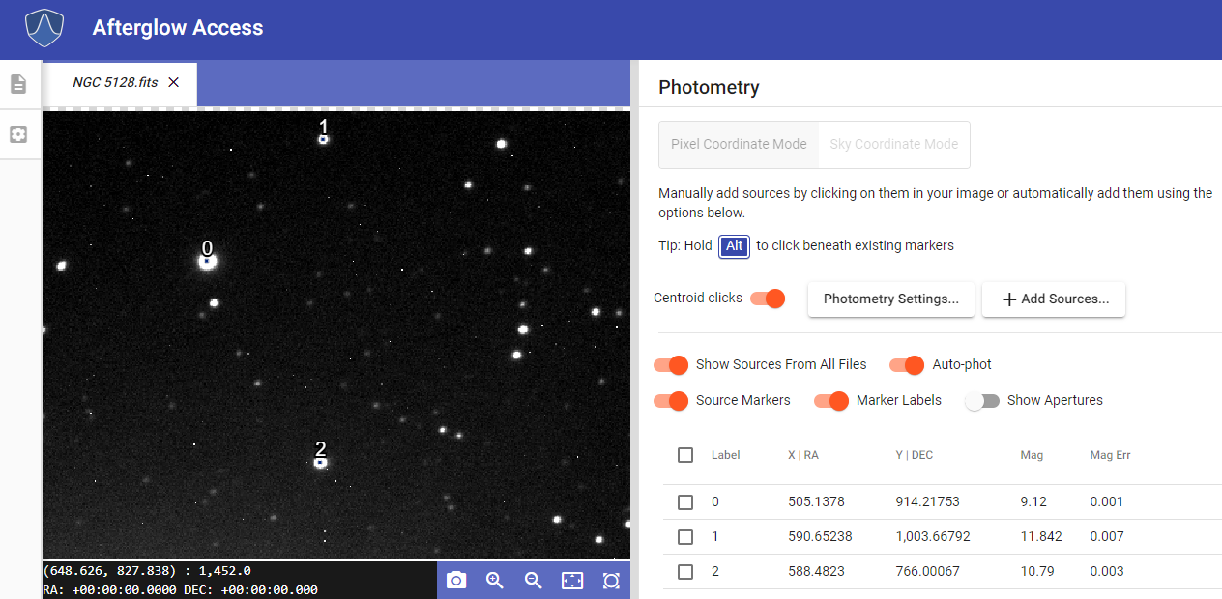
Caption: The left-hand portion of the image has an image of an irregular galaxy NGC 5128. The image is zoomed in to the top middle portion of the entire image of the galaxy. Therefore, there are no discernible features, except several stars. Three of the stars have a small blue dot located on their centers. These same stars are also labeled 0, 1, and 2. The right half of the image shows the upper portion of the Photometry tool panel. Three sources are shown in the Photometry list. These are the sources that are labeled 0, 1, and 2.

The “Show Apertures” toggle button shows the area around the star or point used to calculate the magnitude. The default setting for this toggle button is off.
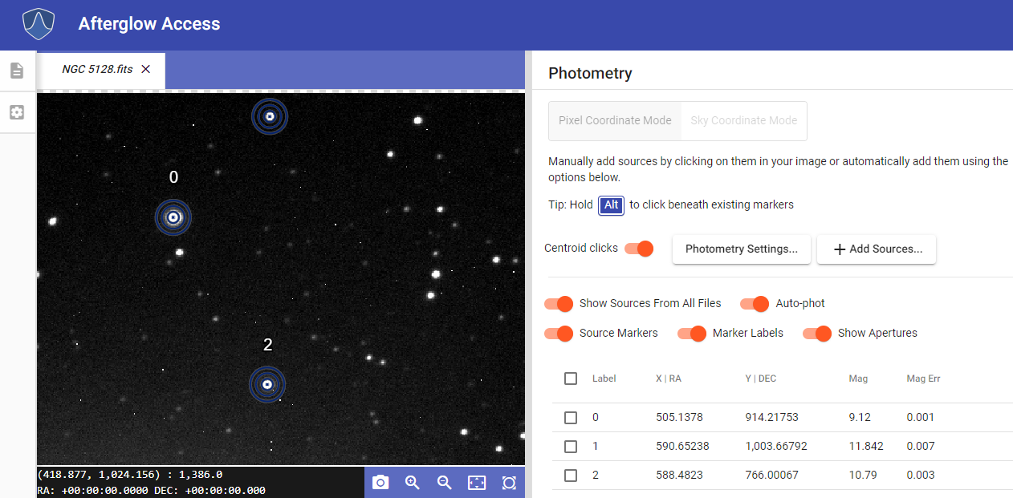
Caption: The left-hand portion of the image has an image of an irregular galaxy NGC 5128. The image is zoomed in to the top middle portion of the entire image of the galaxy. Therefore, there are no discernible features, except several stars. Three of the stars have a small blue dot located on their centers, and are surrounded by a blue circular outline. These same stars are also labeled 0, 1, and 2. The right half of the image shows the upper portion of the Photometry tool panel. Three sources are shown in the Photometry list. These are the sources that are labeled 0, 1, and 2.

Five other buttons are available at the bottom of the Photometry tool panel.

The first one is Merge Selected Sources and becomes available after selecting more than one source or star. The Merge Selected Sources button allows the user to tell AgA that two or more markers are representing the same source, such as a moving asteroid. Then, AgA will extrapolate or interpolate that source’s position throughout the remaining images.
The second one is Remove Selected Sources, and it will remove the selected sources from the list of stars or points that the user has measured.
The third button, Remove All Sources, will remove all sources from the list. It is important to note that AgA will continue to count the number of sources. For example, if three sources have already been selected (number 0, 1, and 2), the next point that is selected will automatically be number 3. This occurs whether the previous points have been removed or not.
The fourth button is Update Photometry. If the user has changed any of the Photometry settings during their work, selecting this button will recalculate each source’s magnitude.
The fifth button is Export Data. If this button is selected, the user can download all of their current data to their computer. The data will be saved into a spreadsheet labeled afterglow_sources.
After a bit of practice with a single image, the user may want to try batch photometry if they are working with multiple images at the same time. This can be accomplished through the “Select Image(s) to Photometer” drop-down menu, which is located below the Merge Selected Sources button.
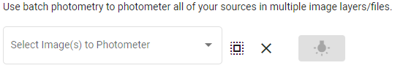

If the user clicks the drop-down menu, then they will see every image that they currently have open.
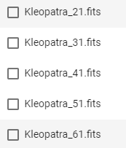

Once this drop-down menu is open, the user can select the images that they want their previously selected point sources measured in. If the user wants all of the images in their file library list photometered, then they can click on the icon (square with an outline of dots) to the right of the “Select Image(s) to Photometer” drop-down menu. If they want to deselect all of the files, they can click on the X icon to the right of this icon. Once the desired files are chosen, they can select the Batch Photometry button. This button is located to the right of the X icon.
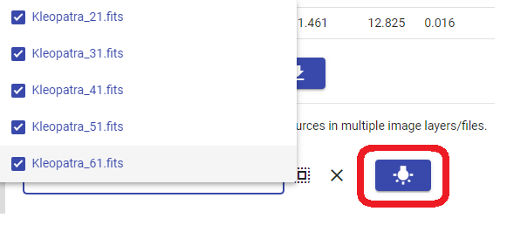
Caption: The “Select Image(s) to Photometer” drop-down menu is shown on the left side of the image. The drop-down menu is open and five Kleopatra images are shown and selected. The Batch Photometry button is also outlined in red for added emphasis. This button is located near the bottom right of the image.
After this button is selected, another button will be available below the drop-down menu. This allows the user to download their new data to their computer.
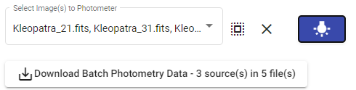

10 Back to Table of Contents

PIXEL OPERATIONS
Keyboard Shortcut “*”

The Pixel Operations tool allows the user to perform certain arithmetic and mathematical operations to an image on a per-pixel basis.
Simple Settings
There are two settings options within the Pixel Operations tool. The default is Simple settings.

Select a Mode
The “Select a mode” drop-down menu allows the user to choose between three different modes. From top to bottom, these modes are Scalar, Image, and kernel Filter.
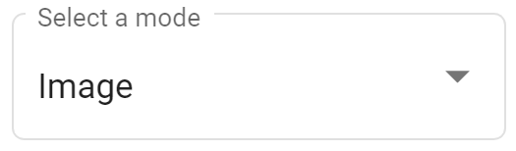
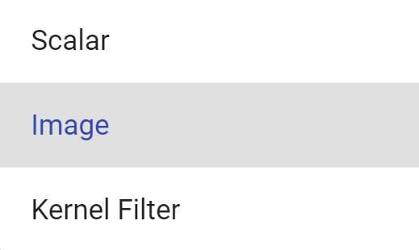
Caption: Shown above is the “Select a mode” drop-down menu in the Simple Settings of the Pixel Operations tool. The options available in the list, from top to bottom, are Scalar, Image, and Kernel Filter.

Image Mode
The Image mode allows the user to perform simple arithmetic on two images. It is the default mode in Simple settings.

Selected Image(s) Drop-Down Menu
The “Selected Image(s)” drop-down menu is not a typical drop-down menu. This menu is automatically filled in based on the image that is currently open in the display window. For example, if the user currently has NGC 5128.fits in the AgA display window, this will be the file in this drop-down menu.

Additional Image(s) Drop-Down Menu
The “Additional Image(s)” drop-down menu allows the user to select other images that they want the specified arithmetic performed on. The user can choose from any files that are currently open in their file library list.

If the user wants to perform the arithmetic on all of the images in their file library list, they can click on the icon (square with an outline of dots) to the right of the “Additional Image(s)” drop-down menu.
If the user wants to remove all of their selected images, they can click on the X icon that is to the right of the “Additional Image(s)” drop-down menu.
Select an Operand Drop-Down Menu
The “Select an Operand” drop-down menu allows the user to select the operation that they would like performed on every image. The four operands, from top to bottom, are Add, Subtract, Multiply,” and Divide. As the name of the tool suggests, this operation is performed on a per-pixel basis, and it is repeated for every single pixel.
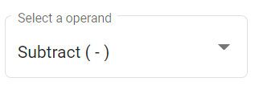
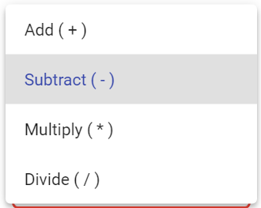
For example, imagine that a certain pixel in the image that is currently displayed has a value of 6. The pixel located in the same position in the image selected in the drop-down menu described below has a value of 2. If “Add” is selected, the pixel in the same location in the new image will have a value of 6 + 2 = 8. If “Subtract” is selected, the pixel in the same location in the new image will have a value of 6 - 2 = 4. If “Multiply” is selected, the pixel in the same location in the new image will have a value of 6 * 2 = 12. If “Divide” is selected, the pixel in the same location in the new image will have a value of 6 / 2 = 3.

Select an Image Drop-Down Menu
The “Select an Image” drop-down menu allows the user to choose the image that will be used in the various operations.

To the right of this drop-down menu is the Overwrite Files button. The default for this button is off. If this button is off, then new files will be created with the pixel operations.
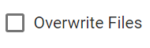
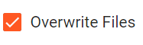
For example, if one file was selected in the “Additional Image(s)” drop-down menu, then two new files will be created: one for the operation that occurred with the file automatically selected in the “Selected Image(s)” drop-down menu and the file in the “Select an Image” drop-down menu, and one for the operation that occurred between the file in the “Additional Image(s)” drop-down menu and the file in the “Select an Image” drop-down menu. If the Overwrite Files button is selected, then the files in the “Selected Image(s)” and “Additional Image(s)” drop-down menus (the original files) will be modified.

For example, imagine that the user currently has the file NGC 5128.fits open. This means that this file is the file selected in the “Selected Image(s)” drop-down menu. They also have selected Kleopatra_01.fits in the “Additional Image(s)” drop-down menu. They also have selected Add as their operand. They have selected Kleopatra_61.fits as the file in the “Select an Image” drop-down menu, and the Overwrite Files button is not selected. Two new files will be created. The first file will be the image that results when Kleopatra_61.fits is added to NGC 5128.fits. The second file will be the image that results when Kleopatra_61.fits is added to Kleopatra_01.fits.

Scalar Mode
The Scalar mode allows the user to perform simple arithmetic between an image and a scalar value (any real number). It is the first mode on the “Select a Mode” drop-down menu.
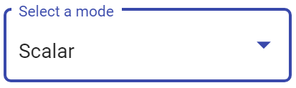

Selected Image(s) Drop-Down Menu

The “Selected Image(s)'' drop-down menu is not a typical drop-down menu. This menu is automatically filled in based on the image that is currently open in the display window. For example, if the user currently has NGC 5128.fits in the AgA display window, this will be the file in this drop-down menu.

Additional Image(s) Drop-Down Menu
The “Additional Image(s)” drop-down menu allows the user to select other images that they want the specified arithmetic performed on. The user can choose from any files that are currently open in their file library list.
If the user wants to perform the arithmetic on all of the images in their file library list, they can click on the icon (square with an outline of dots) to the right of the “Additional Image(s)” drop-down menu.
If the user wants to remove all of their selected images, they can click on the X icon that is to the right of the “Additional Image(s)” drop-down menu.
Select an Operand Drop-Down Menu
The “Select an Operand” drop-down menu allows the user to select the operation that they would like performed on every image. The four operands, from top to bottom, are Add, Subtract, Multiply, and Divide. As the name of the tool suggests, this operation is performed on a per-pixel basis, and it is repeated for every single pixel.
For example, imagine that a certain pixel in the image that is currently displayed has a value of 6. The scalar value specified in the box described below is 2. If “Add” is selected, the pixel in the same location in the new image will have a value of 6 + 2 = 8. If “Subtract” is selected, the pixel in the same location in the new image will have a value of 6 - 2 = 4. If “Multiply” is selected, the pixel in the same location in the new image will have a value of 6 * 2 = 12. If “Divide” is selected, the pixel in the same location in the new image will have a value of 6 / 2 = 3.

Specify a Scalar Value Box
The Specify a Scalar Value box allows the user to choose their scalar value. This value can be positive or negative, and it can include decimal points.
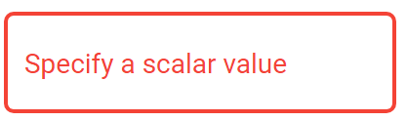
To the right of this box is the Overwrite Files button. The default for this button is off. If this button is not selected, then the resulting images will be added to the user’s file library. If this button is selected, then the user’s original files will be modified.

Kernel Filter
The Kernel Filter mode allows the user to apply a variety of Kernel Filters to an image. It is the third and final mode on the “Select a Mode” drop-down menu.
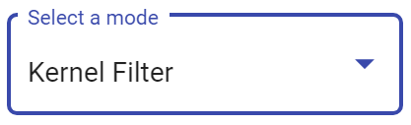
Selected Image(s) Drop-Down Menu
The “Selected Image(s)” drop-down menu is not a typical drop-down menu. This menu is automatically filled in based on the image that is currently open in the display window. For example, if the user currently has NGC 5128.fits in the AgA display window, this will be the file in this drop-down menu.
Additional Image(s) Drop-Down Menu
The “Additional Image(s)” drop-down menu allows the user to select other images that they want the specified Kernel Filter applied to. The user can choose from any files that are currently open in their file library list.
If the user wants to apply the kernel filter to all of the images in their file library list, they can click on the icon (square with an outline of dots) to the right of the “Additional Image(s)” drop-down menu.
If the user wants to remove all of their selected images, they can click on the X icon that is to the right of the “Additional Image(s)” drop-down menu.
Kernel Filter Drop-Down Menu
The “Kernel Filter” drop-down menu allows the user to choose which Kernel Filter they would like to apply to the image. The default Kernel Filter is Median. Kernel Filters can be used for specific purposes, such as blurring and sharpening. If you want to learn more about the various Kernel Filters that can be applied, please visit https://docs.scipy.org/doc/scipy/reference/ndimage.html for more information.

Kernel Size Drop-Down Menu
The “Kernel Size” drop-down menu allows the user to choose the size of their Kernel Filter. The default Kernel Size is 3 x 3, and the only other option is 5 x 5.
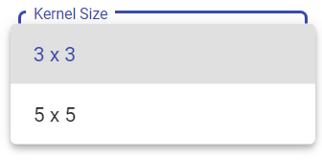
To the right of this box is the Overwrite Files button. The default for this button is off. If this button is not selected, then the resulting images will be added to the user’s file library. If this button is selected, then the user’s original files will be modified.
Essentially, a Kernel Filter, like the other modes, changes the values of individual pixels. The specific Kernel Filter specifies how the pixels will be changed. Imagine that the defaults for the previous drop-down menus are selected: median and 3 x 3. In this scenario, the median Kernel Filter will take the specific pixel that is being modified and center it in a 3 x 3 grid. The filter will look at the values of each of the pixels in this 3 x 3 grid, and arrange them in ascending order. It will then take the median value (the value in the middle), and assign that value to the pixel. It will then repeat this process on a per-pixel basis for the rest of the image.

Submit
Once the user is satisfied with their selections, they can select the Submit button to actually perform the pixel operations.
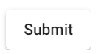
If this process was successful, a green dialogue box will appear at the bottom of the Pixel Operations tool panel. It will state, “Processing is complete.”
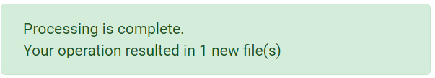
If this process was not successful, a red dialogue box will appear at the bottom of the Pixel Operations tool panel. An example of an error that would cause this unsuccessful processing is if the user tries to perform simple arithmetic on two images that are not the same size in the Image mode.
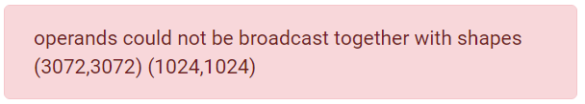

Advanced Settings
Using the Advanced Settings, a user can process complex batch data. For example, this is a way that the user can perform one long string of operations on the image at one time. The user is encouraged to explore all of the options in the Advanced Settings, but for the purposes of this manual, they will not be explained.
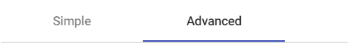

11 Back to Table of Contents

WCS CALIBRATION
Keyboard Shortcut “w”

The WCS Calibration tool is an AgA tool that allows users to add right ascension and declination to some non-WCS images.

WCS stands for World Coordinate System. This system maps the pixels in the data to the right ascension and declination coordinates in the night sky. The WCS Calibration tool uses an algorithm that compares the relative positions of stars to a database. Therefore, there needs to be enough stars in the image in order for the algorithm to work. For more information about the World Coordinate System and how the algorithm works, visit astrometry.net.
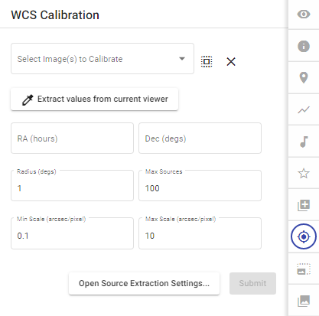

Caption: When the WCS Calibration tool is opened, this is the initial view of the WCS Calibration tool panel. There is the “Select Image(s) to Calibrate” Drop-Down Menu located on the top. Beneath this is the Extract Values from Current Viewer button. Underneath this button are different values that guide the WCS calibration. Finally, beneath these values are the Open Source Extraction Settings button and the Submit button.
Select Image(s) to Calibrate Drop-Down Menu
The first drop-down menu for the WCS Calibration tool is “Select Image(s) to Calibrate”. In this drop-down menu, it gives the user the option to choose any of the images that are uploaded to their file library list. To choose the images, select the drop-down menu, then click on the files to be calibrated. Once an image is selected, the box to the left of it will turn blue with a white checkmark and the text of the image will also turn blue. If the user wishes to deselect an image, simply click on it again.
If the user wants to calibrate all of the images in their file library list, click on the icon (square with an outline of dots) to the right of the “Select Image(s) to Calibrate” drop-down menu.
If the user wants to remove all of the selected images, click on the X icon that is to the right of the “Select Image(s) to Calibrate” drop-down menu.

Extract Values from Current Viewer Button
The button directly underneath the “Select Image(s) to Calibrate” drop-down menu is the Extract Values From Current Viewer button. Once selected, the information below this button is automatically filled in based on the image that is currently in the display window. In order for this button to appear, there must be an image currently open in the display window. The user can start the algorithm blind; however, if this button is selected, it fills in some of the boxes with information from the image’s file information header. The information that is given provides the center for the search.
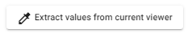

RA (Hours) and Dec (Degs) Boxes
The RA (hours) and Dec (Degs) boxes allow for the input of right ascension and declination for the algorithm. If the image is already WCS-calibrated, when the user clicks on the Extract Values from Current Viewer button, these boxes will automatically have the RA and Dec of the image. As stated, the RA is listed in hours, minutes, and seconds, and the Dec is listed in degrees, minutes, and seconds.
If the user knows the approximate RA and Dec for the image, then they can enter this information and it gives the algorithm a starting search point. Essentially, it acts as the center of the search.
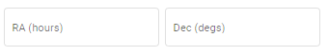
Radius (Degs) Box
The Radius (degs) box allows for the input of the search radius around the indicated RA and Dec of the image.
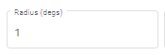
Max Sources Box
The Max Sources box limits the number of sources entering the algorithm. It helps decrease the search time if the image has many sources, like a globular cluster.
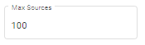
Min Scale (arcsec/pixel) and Max Scale (arcsec/pixel) Boxes
The Min Scale (arcsec/pixel) and Max Scale (arcsec/pixel) boxes allow the user to choose the estimated scale of the image. Given the image, these values may be chosen when the user clicks on the Extract Values from Current Viewer button.
The Min Scale (arcsec/pixel) box controls the minimum number of arcsecs that can be present in each pixel. Similarly, the Max Scale (arcsec/pixel) box controls the maximum number of arcsecs that can be present in each pixel.
Both of these boxes control the size of the triangles used in the algorithm.
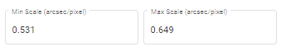

Open Source Extraction Settings Button
The Open Source Extraction Settings button opens the source extraction settings. The user is free to explore these settings, but for the purposes of this manual, they will not be explained.
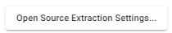
Submit Button
Once the user is satisfied with the information inputted in each box, the user can select the Submit button to start the calibration process. Once this button is selected, the user will receive a pop-up that says that the WCS Calibration is completed. It will either say that a solution was found or that it failed to find a solution. If it failed to find a solution, then RA and Dec were not added to the image.
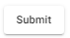

12 Back to Table of Contents

ALIGNER
Keyboard Shortcut “a”

The Aligner is an AgA tool that allows the users to take a selected group of similar images and align or position them with regard to one of the previously selected images. Currently, the only option is to align them astrometrically. In other words, the right ascension and declination of these images will be matched so that each pixel represents the same position in the night sky.
Select Image(s) to Align Drop-Down Menu
The first drop-down menu for the aligning tool is “Select Image(s) to Align”. In this drop-down menu, it gives the user the option to choose any of the images that are uploaded to their file library list. To choose the images, select the drop-down menu, then click on the files to be aligned. Once an image is selected, the box to the left of it will turn blue with a white checkmark and the text of the image will also turn blue (reference the image below). If the user wishes to deselect an image, simply click on it again.
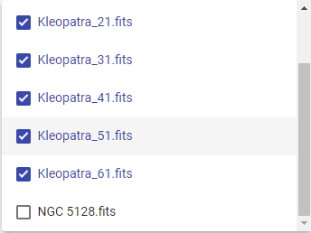
If the user wants to align all of the images in their file library list, click on the icon (square with an outline of dots) to the right of the “Select Image(s) to Align” drop-down menu.
If the user wants to remove all of the selected images, click on the X icon that is to the right of the “Select Image(s) to Align” drop-down menu.
Reference Image File Drop-Down Menu
The second drop-down menu is “Reference Image File”. It is located directly beneath the “Select Image(s) to Align” drop-down menu. This drop-down menu allows the user to choose only one image, and the only options are the images that have been chosen in the “Select Image(s) to Align” drop-down menu. The image that is chosen in this drop-down menu is the image that all of the other images will be aligned to.
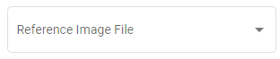
Mode Drop-Down Menu
The third drop-down menu is “Mode”. It is located directly beneath the “Reference Image File” drop-down menu. Currently, the only option for the “Mode” drop-down is astrometric. This mode means that it aligns the right ascension and declination values of the pixels using the image’s WCS calibration. For more information on WCS calibration, reference the glossary, the WCS Calibration section, or the WCS subsection of the File Info section.

Crop to Largest Overlapping Region Toggle Button
Directly below the “Mode” drop-down menu is the “Crop to Largest Overlapping Region” toggle button. The default for this button is on. When this button is toggled on, it will crop to the largest shared area of right ascension and declination.

When this button is toggled off, each image is cropped to a slightly different size. The reference remains uncropped, but each of the other images are cropped so that the right ascension and declination are located in the same pixel position. This is what creates the slightly different image dimensions.
Submit Button
Once the user has selected the images that they want aligned, and have also chosen the reference image, they can align the images using the Submit button. This button is located beneath the “Crop to Largest Overlapping Region” toggle button. The user will not be able to click on this button if the first two drop-down menus do not contain images.
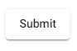
The user will know that AgA is processing the request once a loading bar appears beneath the Submit button.
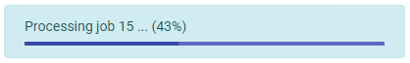

Moreover, the user will know that the request has been completed once the loading bar has the message “Processing is complete” and bullet points appear to the right of each selected image in the file library list (on the left-hand side of the AgA window).
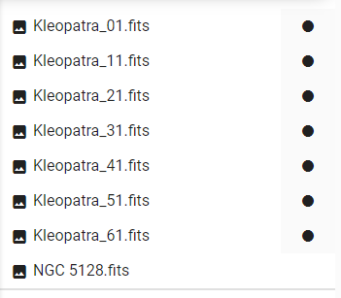
It is important to note that for the above image of the file library list, all of the Kleopatra files would be aligned to one of the Kleopatra images. Additionally, the “Crop to Largest Overlapping Region” toggle button would have been on because each image has a circle to the right of its name. However, if this was toggled off, then the reference image would not have had a circle to the right of its name.

13 Back to Table of Contents

STACKER
Keyboard Shortcut “shift + S”

The Stacker is an AgA tool that allows the user to combine multiple images into a single image.
Before utilizing the Stacker tool, it is most beneficial to align the images using the Aligner tool. This will ensure that the same object, like a star (which should be stationary), will not appear multiple times in the image.
For example, the image below shows seven Kleopatra images stacked without using the Aligner tool. Notice how the star appears multiple times in the image, even though Kleopatra should be the only moving object.
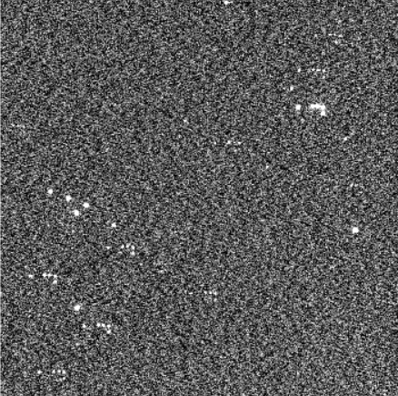
Caption: Shown above is the stacked image of asteroid Kleopatra. The images were not aligned prior to stacking. Therefore, the star in the image appears multiple times in the upper right-hand corner.

Select Image(s) to Stack Drop-Down Menu
The “Select Image(s) to Stack” drop-down menu allows the user to select the images that they want to stack.
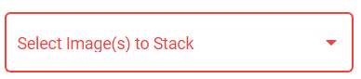
If the user wants to stack all of the images in their file library list, they can click on the icon (square with an outline of dots) to the right of the “Select Image(s) to Stack” drop-down menu.
If the user wants to remove all of their selected images, they can click on the X icon that is to the right of the “Select Image(s) to Stack” drop-down menu.
Mode Drop-Down Menu
The “Mode” drop-down menu allows the user to choose the mode that will be used during the stacking. The mode determines how the values of the same pixel in each image will be combined into a single value. The default mode is average, which averages the values from each image to create a single value. There are three other modes, and they are percentile, mode, and sum. The user is encouraged to explore the differences between these modes.
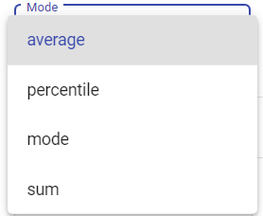

Rejection Drop-Down Menu
The “Rejection” drop-down menu allows the user to choose how certain pixel values are rejected before they are combined. It essentially specifies whether any of the values need to be disregarded from the combination. The default rejection type is none, which means that no rejection is occurring. There are four types of rejection: chauvenet, iraf, minmax, and sigclip. The user is encouraged to explore the differences between these rejection types.
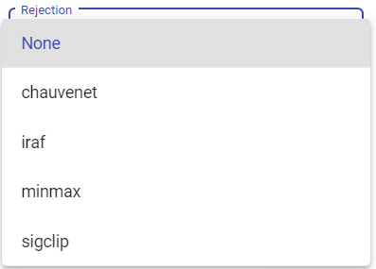
Scaling Drop-Down Menu
The “Scaling” drop-down menu allows the user to choose how certain pixel values are scaled as they are combined. Scaling is a way to shift the values so they are normalized, or on the same level. The default scaling type is none, which means that no scaling is occurring. There are three types of scaling: average, median, and mode. The user is encouraged to explore the differences between these scaling types.

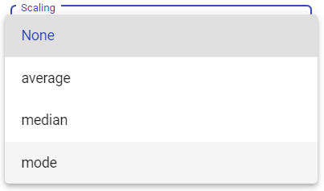

Submit Button
Once the user has chosen the images that they want to stack and selected their wanted mode, rejection, and scaling type, they can select the Submit button.
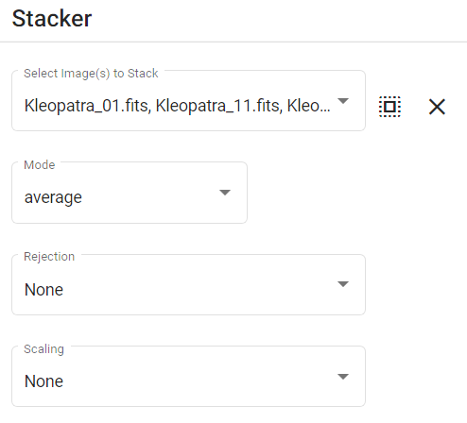
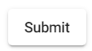
Caption: Above is an example of the settings that could be used to stack multiple images of Kleopatra (the files ending in 01, 11, 21, 31, 41, 51, and 61) and the Submit button. These images are in the “Select Image(s) to Stack” drop-down menu. Average is selected in the “Mode” drop-down menu, and no rejection or scaling types are selected.

If the images stack successfully, then a green dialogue box will appear beneath the Submit button. It will state, “Processing is complete.” The new stacked image will appear in the user’s file library list.

Below is a picture of a successfully aligned and stacked image of seven asteroid Kleopatra files.
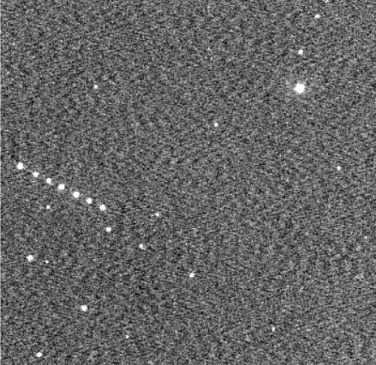
Caption: Above is a stacked image of seven asteroid Kleopatra images. There are several stars throughout the image. There are also seven dots that form a diagonal line near the middle left-hand side of the image. Each of the dots represents Kleopatra, and it showcases how Kleopatra moves across the sky.

As an additional way to experience and enjoy the stacked images, open the stacked image file in the Sonification tool.

14 Back to Table of Contents

LINKS TO RESOURCES
Here are several additional resources that could be helpful for using and understanding AgA.
- AgA Demonstration: https://us02web.zoom.us/rec/share/xmakw57iG6hcxCgDGazj2Em7OXpyR9yADdBhH6AVnkp-In2sUjC0GPPyEw1qZBm7.jjFRwx4257c0A90u

- AgA Video Tutorials: https://www.youtube.com/watch?v=1J7Djv510-E&list=PLy034wwN98YIybjCMuF0Fd7flo62C9jYZ&index=4

- Accessible AgA Video Tutorials: https://www.youtube.com/user/introastro/playlists

- IDATA Website: https://idataproject.org/……………………………………………………

- Kernel Filter Definitions: https://docs.scipy.org/doc/scipy/reference/ndimage.htm….

- WCS Calibration Information: astrometry.net…………………………………………….

15 Back to Table of Contents

GOING DEEPER
The purpose of the following Going Deeper sections is to help guide the user through specific activities that reinforce their understanding of the different AgA tools.

15-a Back to Table of Contents

Display Settings: Going Deeper

This Going Deeper activity will utilize and compare the differences between the brightness presets found in the Display Settings tool. As a reminder, these presets are Default, Faint Target, and Bright Target. Ultimately, this activity will answer the question, “How can using various brightness presets alter the way an image is viewed?”

The Needed Files
If more guidance is needed on opening a file, see the “Files and the File Library List” section above.

Open the NGC 5128.fits file:
- Click on the Open Files button.
- Select the Sample folder.
- Select the Deep Sky Objects folder.
- Select the NGC 5128.fits file.

Next, open the Kleopatra_01.fits file:
- Click on the Open Files button.
- Select the Sample folder.
- Select the Solar System folder.
- Select the Asteroid 216 Kleopatra folder. There should be 68 images in this folder.
- Select the Kleopatra_01.fits file.

Finally, open the Trifid Nebula.fits file:
- Click on the Open Files button.
- Select the Sample folder.
- Select the Deep Sky Objects folder.
- Select the Trifid Nebula.fits file.

The Assigned Presets
Now that all of the needed files are in the file library list, open the Display Settings tool. Ensure that the image of NGC 5128 is being viewed with the Default brightness preset. Additionally, select the Bright Target button for the Kleopatra file and the Faint Target button for the image of the Trifid Nebula. The Default brightness preset was chosen for NGC 5128 because it allows the user to see the details of the image most clearly. The Bright Target preset was chosen for the Kleopatra file because it helps reduce some of the noise in the image, and it makes it easier to locate Kleopatra in the image. The Faint Target preset was chosen for the Trifid Nebula because it highlighted and accentuated the gas structure in the image.

The next part of this Going Deeper section will walk the user through one comparison of the various display settings. However, before reading the next section, the user is encouraged to briefly explore and compare the various images in the other settings that are available outside of the assigned setting above. Try to observe how the assigned setting highlights the image's features allowing for more detailed observations to be made.

Comparing Brightness Presets
Below are three images of NGC 5128 in the three different brightness presets. Observe how the assigned preset allows for the most discernible interpretation of the galaxy’s gas disk and bright center.

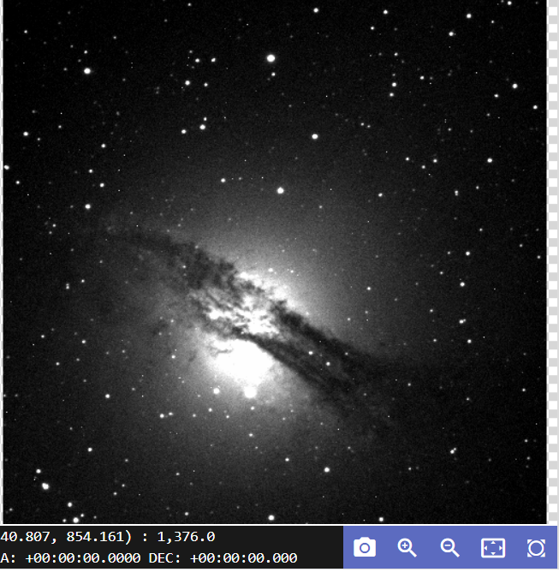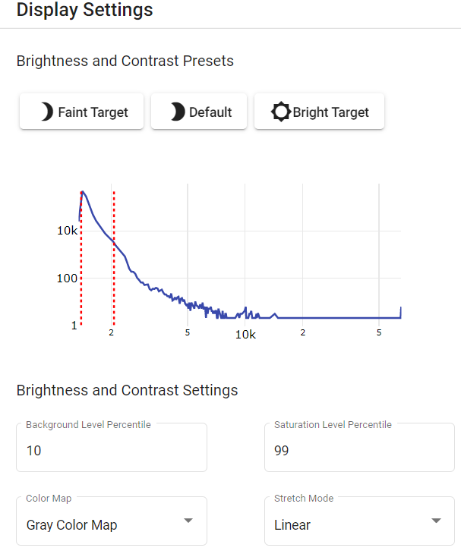
Caption: Shown above is NGC 5128 in the assigned Default setting. The left-hand portion of the image has an image of an irregular galaxy NGC 5128. The image has a gas disk stretching from the left middle to the lower right with a brighter sphere in the middle. The right half of the image has a histogram. The x-axis represents the brightness, or intensity, of a pixel. The y-axis represents the number of pixels at the given brightness.

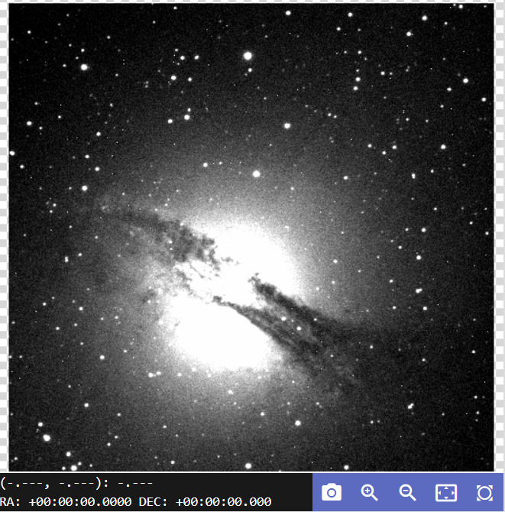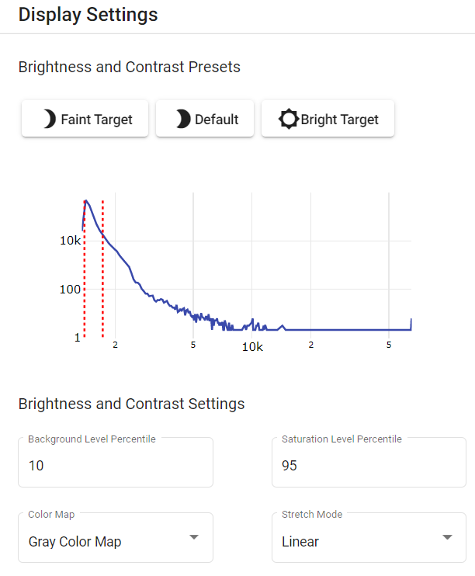
Caption: Shown above is NGC 5128 in the Faint Target setting, which displays the gas disk in less detail than the assigned setting. The left-hand portion of the image has an image of an irregular galaxy NGC 5128. The image has a gas disk stretching from the left middle to the lower right with a brighter sphere in the middle. The right half of the image has a histogram. The x-axis represents the brightness, or intensity, of a pixel. The y-axis represents the number of pixels at the given brightness.

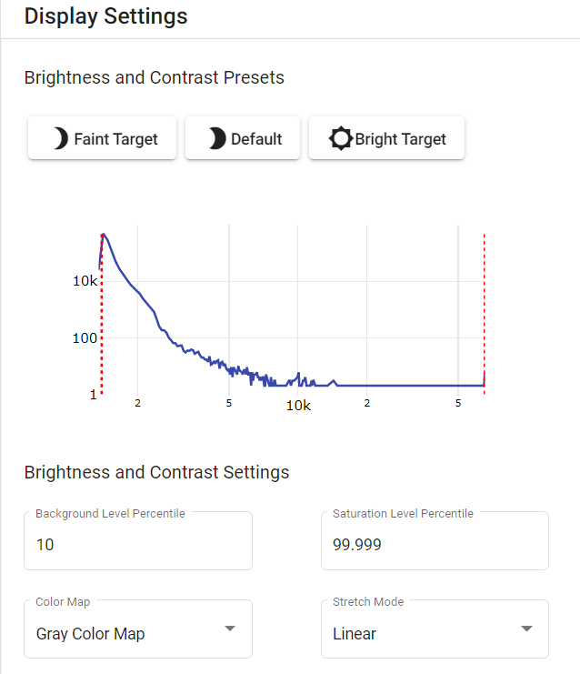
Caption: Shown above is NGC 5128 in the Bright Target setting. The left-hand portion of the image has an image of an irregular galaxy NGC 5128. Due to the brightness display setting, only two stars are visible in the image. The right half of the image has a histogram. The x-axis represents the brightness, or intensity, of a pixel. The y-axis represents the number of pixels at the given brightness.
Comparing Brightness Presets On Your Own
Below are the images of Kleopatra and the Trifid Nebula in their assigned preset. Now, try comparing them on your own. Open the Kleopatra_1.fits file. Compare the image to the image of Kleopatra in its assigned preset below. Now, toggle between the different Brightness and Contrast presets.

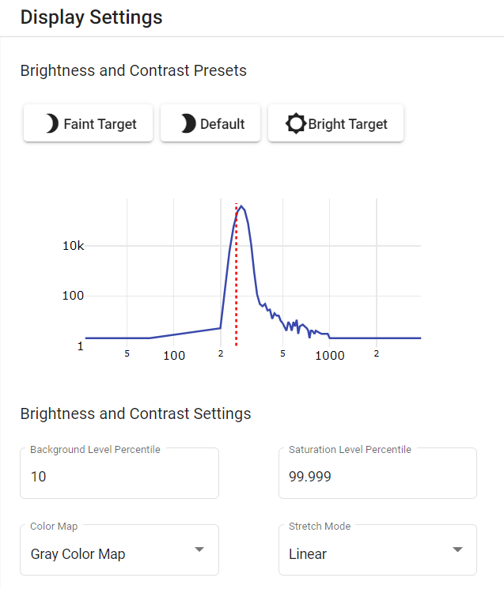
Caption: Shown above is the asteroid Kleopatra image in its assigned Bright Target preset. The left-hand portion of the image has an image of Kleopatra. The image does not show the background noise. Rather, it only contains the asteroid and one star. The right half of the image has a histogram. The x-axis represents the brightness, or intensity, of the pixels. The y-axis represents the number of pixels at the given brightness.

After comparing the Kleopatra images in each of the presets, open the Trifid Nebula.fits file. Compare the image to the image of the Trifid Nebula in its assigned preset below. Now, toggle between the different Brightness and Contrast presets.
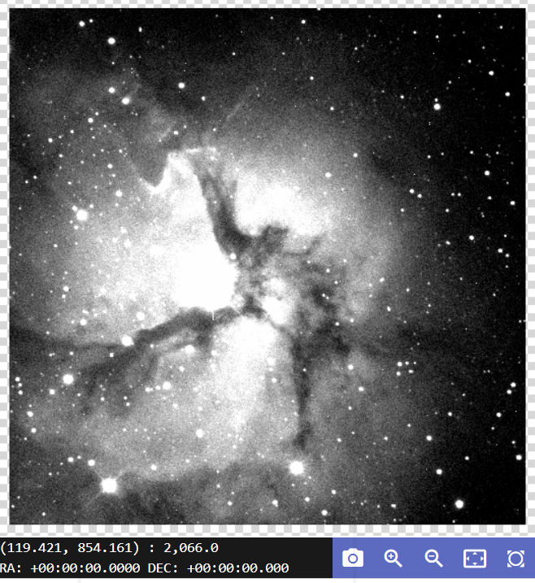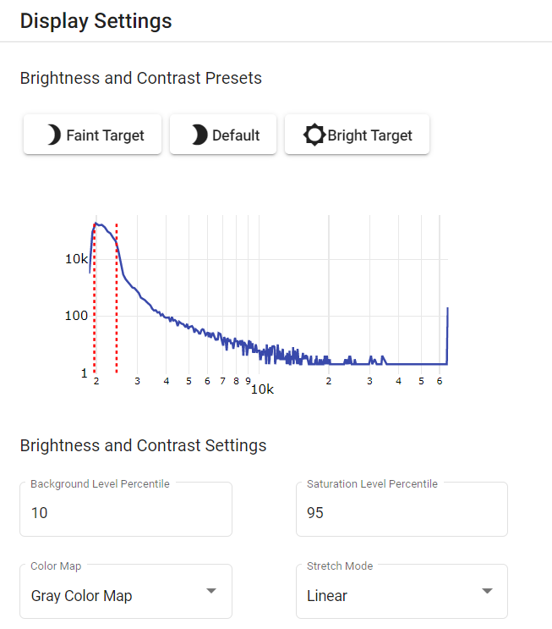
Caption: Shown above is the Trifid Nebula in its assigned Faint Target preset. The left-hand portion of the image contains the image of the Trifid Nebula. The Trifid Nebula is bright in the center, and it contains gas structures that branch out from the center of the image. The right half of the image has a histogram. The x-axis represents the brightness, or intensity, of the pixels. The y-axis represents the number of pixels at the given brightness.

15-b Back to Table of Contents

Sonification: Going Deeper

This activity will show you how the Sonification tool works. Ultimately, the purpose of this Going Deeper activity is to train your ear to recognize and be able to properly utilize the Sonification tool.

Sonifying an Image
First, open the “01_single.fits” file.
- Click on the Open Files button.
- Select the Sample folder.
- Select the Sonification folder.
- Select the “01_single.fits” file.

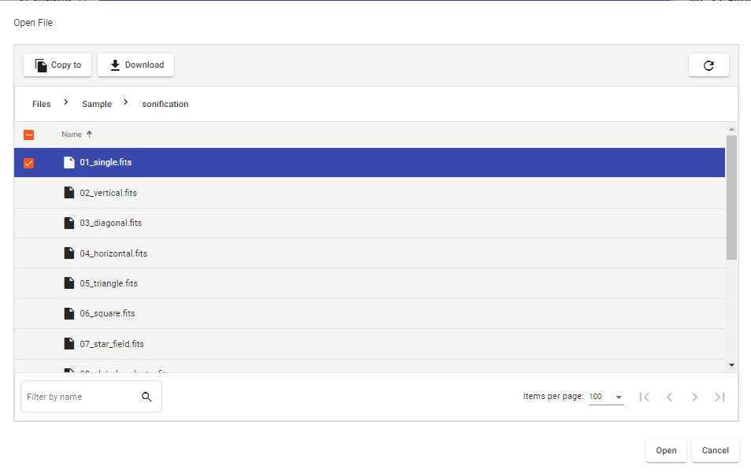
Caption: Above is the window that is shown when looking at the partial list of files in the Sonification folder. The Sonification folder is found in the Sample folder.

Once this file is in the file library list, open the image. Then, select the Zoom to Fit button.

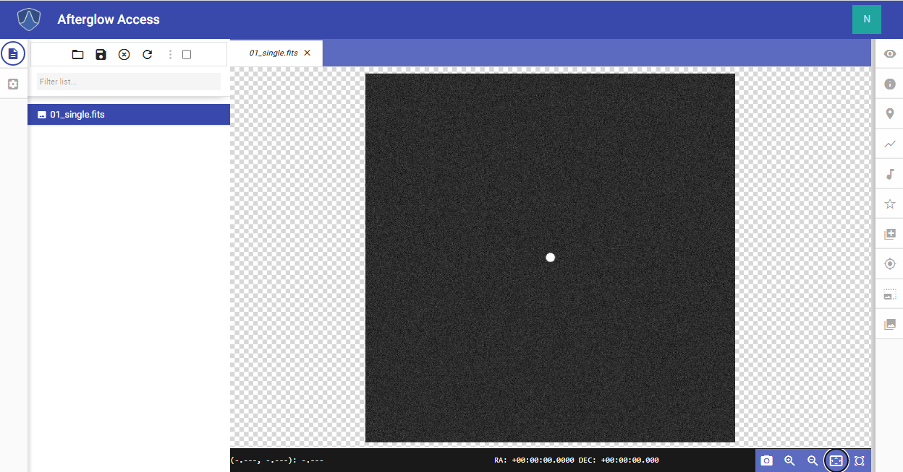
Caption: A picture of the night sky that contains a single bright star/dot is shown in the entire AgA window. The file library list is open on the left side of the image.

Then, select the Show Sonification tab on the right side of the AgA window. Once the Sonification tool panel is open, select the Sonify button at the bottom of the tool panel.

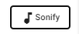

A blue horizontal sonification line will now move up the image. A starting tone will begin the sonification, and a quiet range of tones will be heard as the line moves up. At the midpoint, when it crosses over the bright star, there will be a loud mid-range tone. Then, the quiet range of tones will be heard as the line moves to the top. An ending tone will then indicate when it reaches the end of the image.

Duration and Tones
The default sonification duration is 10 seconds, and the default number of tones is 22 tones. Change the value in the Duration value box to 5 and the value in the Tones value box to 5. This will cause the sonification to occur in 5 seconds with a total of 5 different tones. Then, click on the Sonify button to listen to the difference.
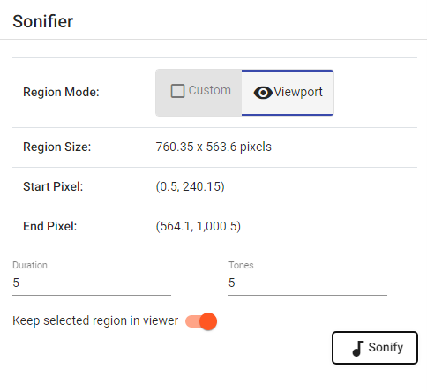

Caption: The Sonification tool panel is shown when the Duration is changed to 5 seconds and there are only 5 tones.

Custom Region Mode
Select the Custom Region Mode button at the top of the Sonification tool panel. Now, select the Mid Time Navigation button. Then, select the Low Tone Navigation button. Finally, click on the Sonify button.
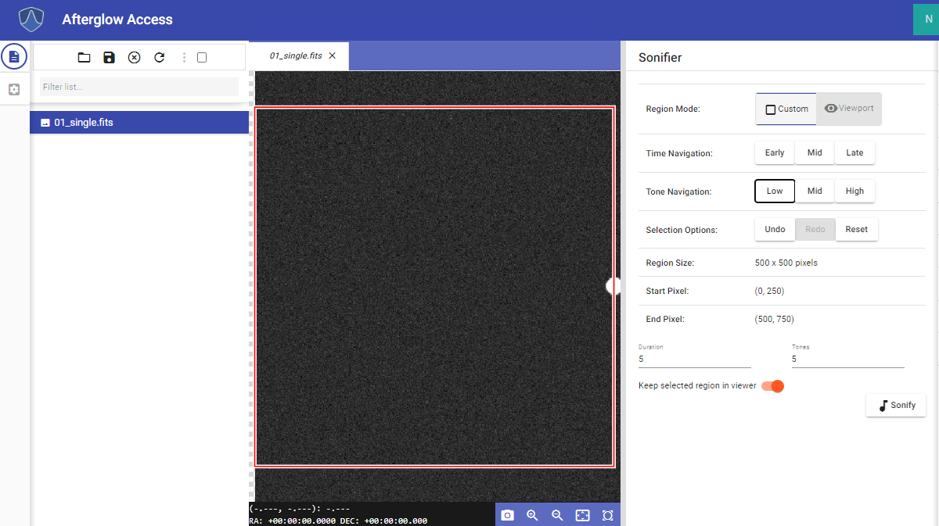
Caption: A picture of the night sky that contains a single bright star/dot in the far right is shown in the entire AgA window. The file library list is open on the left-hand side of the image. The Sonification tool panel is shown with the Custom Region Mode settings.

After listening to the difference, select the Undo button. Then, select the High Tone Navigation button. Finally, click on the Sonify button.

The star is located in a different location of the sonified region, which causes the tone to be different. As you continue to click on the Time Navigation and Tone Navigation buttons, the region that will be sonified will continue to be narrowed down.

Training Your Ear
In the Sonification folder, there are 13 additional images that are beneficial to explore and will help you train your ear.

The second, third, fourth, fifth, and sixth images are similar to the image that was used above, except they have additional stars that are located in different arrangements.

Image “13_asteroid.fits” is a series of images that have been stacked to show an asteroid moving across the sky.

For even more images, navigate to the Shapes folder, which is located in the IDATA folder. The IDATA folder is located in the Sample folder. The Shapes folder contains images of four different shapes that can also be used to train your ear to sonification.

15-c Back to Table of Contents

Aligner: Going Deeper

This is the first activity in a group of three Going Deeper activities that will utilize the Aligner, Stacker, and Custom Markers tools. The activities will be divided according to these sections. Together, these activities will answer the question, “How can astronomers discover or find asteroids?”

This activity will utilize the entire Kleopatra data set. In order to open the data set, follow the instructions below.
- Select the Open Files button.
- Select the Sample folder.
- Select the Solar System folder.
- Select the Asteroid 216 Kleopatra folder. There should be 68 images in the folder.
- Select all of the images by clicking on the box to the left of “Name”. It is located near the top left of the folder directory pop-up window.
- Click on the Open button.

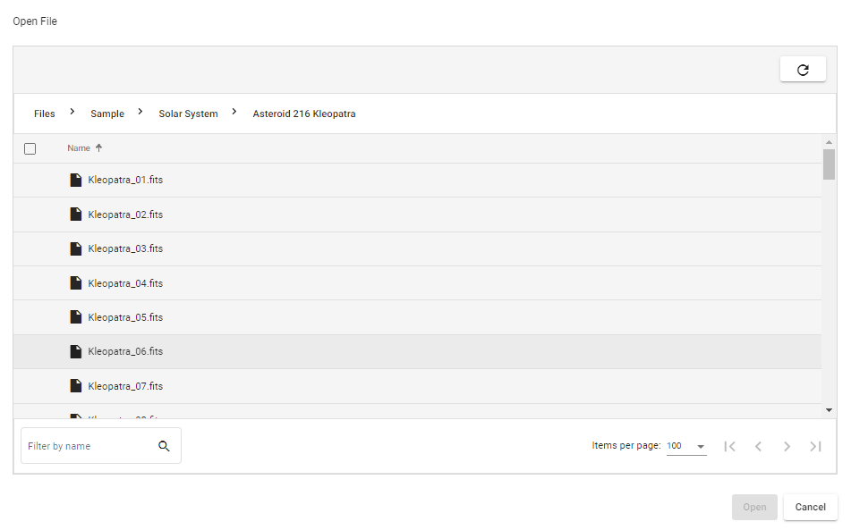
Caption: Above is the window that is shown when looking at the partial list of Kleopatra files in the Asteroid 216 Kleopatra folder. This folder is found in the Solar System folder, which is in turn found in the Sample folder.
Once all of the files are in the file library list, click on the Kleopatra_01.fits file. Select the Zoom to Fit button.

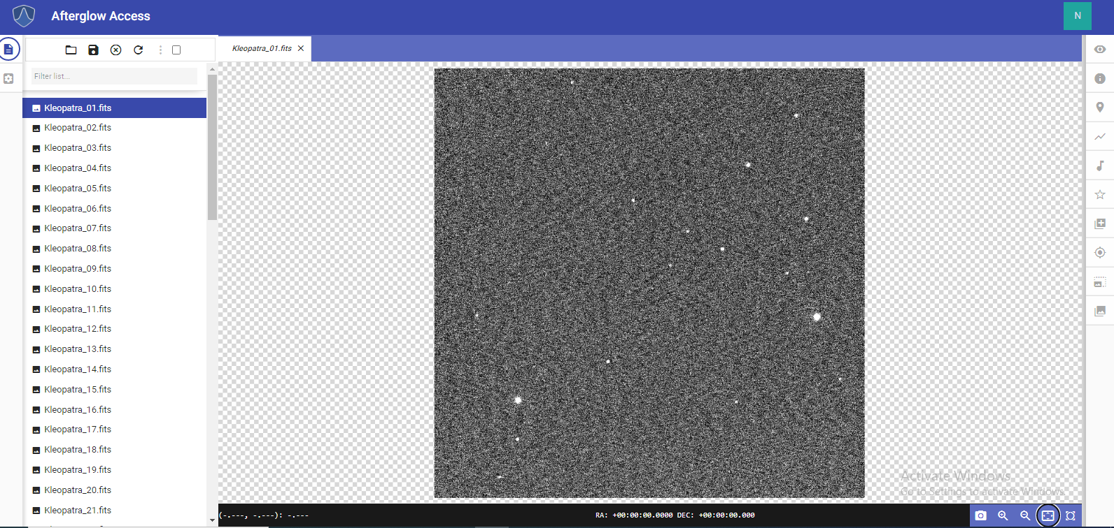

Caption: A picture of the night sky that contains the asteroid 216 Kleopatra is shown in the entire AgA window. The file library list is open on the left side of the image. The image of the night sky is located in the center, and it has several bright dots that appear like stars. One of these dots is Kleopatra.

Now, repeat the same steps with Kleopatra_02.fits and Kleoptra_13.fits. Then, toggle between these three images. It becomes apparent that several of the white dots are either not exactly lined up or are not in the same orientation. This is due to the fact that the telescope is not pointed at the exact same point for all of the images or that the images are rotated in a different direction.

Now, select the Show Aligner tab on the right. If the Kleopatra images are the only files in your file library list, click on the outlined box to the right of the “Select Image(s) to Align” drop-down menu. This button selects all of the images in the file library list. Next, select Kleoptra_01.fits for the file in the “Reference Image File” drop-down menu. Finally, click on the Submit button.

Now, all 68 images are aligned. This ensures that the background stars in the images will line up perfectly, which will allow the images to be stacked successfully.

15-d Back to Table of Contents

Stacker: Going Deeper

This is the second activity in a group of three Going Deeper activities that utilize the Aligner, Stacker, and Custom Markers tools. The activities are divided according to these sections. Together, these activities will answer the question, “How can astronomers discover or find asteroids?”

Note: If you have not completed the Aligner Going Deeper section, go to that section and complete it now.

Now that all of the Kleopatra images have been aligned, select the Show Stacker tab on the AgA toolbar. Then, if there are only Kleopatra images in the file library list, click on the outlined box next to the “Select Image(s) to Stack” drop-down menu. This selects all of the images in the file library list. Then, click on the Submit button.

A new file should appear in the file library list. It should be at the top of the list, and it should start with the word “file” instead of Kleopatra. Go to the file library list, and open this file.

Now, select the Zoom to Fit button.

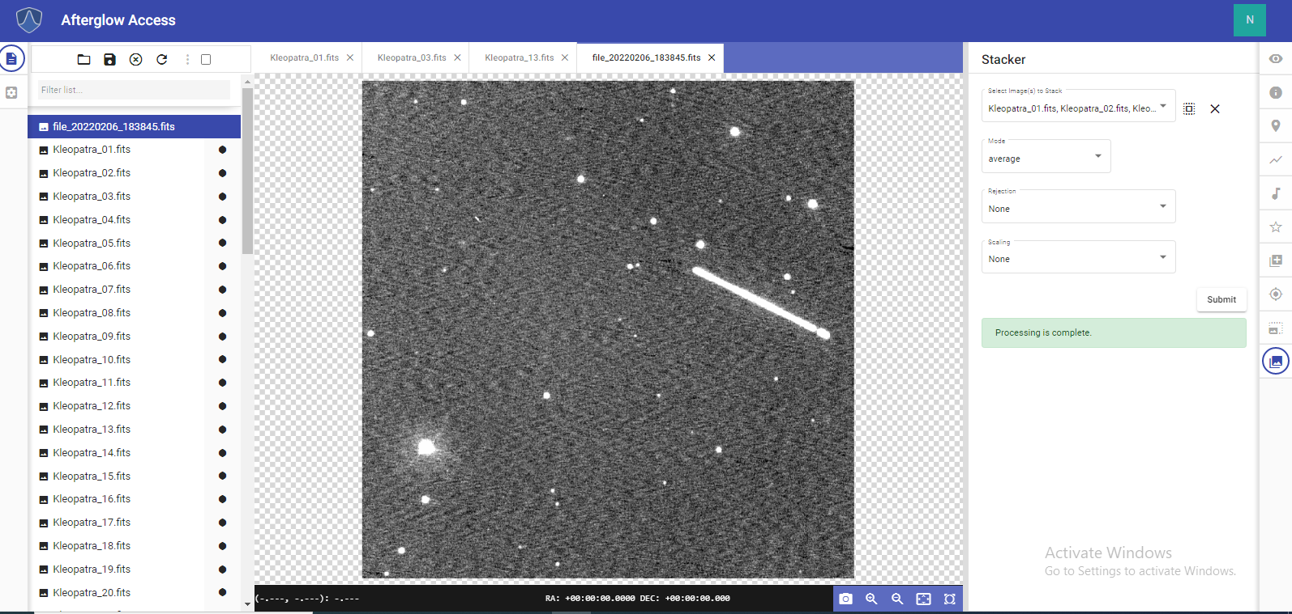

Caption: The stacked image of the Kleopatra files is shown in the entire AgA window. The file library list is open on the left side of the image. The Stacker tool panel is open on the right side of the image. The stacked image is located in the center and features several bright dots (stars) throughout the image. Moreover, near the top right of the image is a diagonal line of light, which is all of the stacked Kleopatra images.

15-e Back to Table of Contents

Custom Markers: Going Deeper

This is the third activity in a group of three Going Deeper activities that utilize the Aligner, Stacker, and Custom Markers tools. The activities are divided according to these sections. Together, these activities will answer the question, “How can astronomers discover or find asteroids?”

Note: If you have not completed the Aligner and/or Stacker Going Deeper sections, go to those activities and complete them now.

Follow the steps to put a custom marker around the diagonal line of Kleopatra images.
- Select the Show Custom Markers tab on the right.
- Click on the image in the middle of the Kleopatra “line” which will add a small circle. Double click on the circle which will turn it orange and will show you the Marker Customization settings.
- Type “Kleopatra” in the Label box.
- Change the value in the Radius value box, so the entire line is in the circle.
- Change the value in the Label Radius value box so the label Kleopatra is just outside the circle.
- Experiment with changing the position of the Label by changing the value in the Label Direction box.
- Experiment with changing the values in the X box and the Y box. Changing the X value will move the marker side to side and changing the Y value will move the marker up and down.

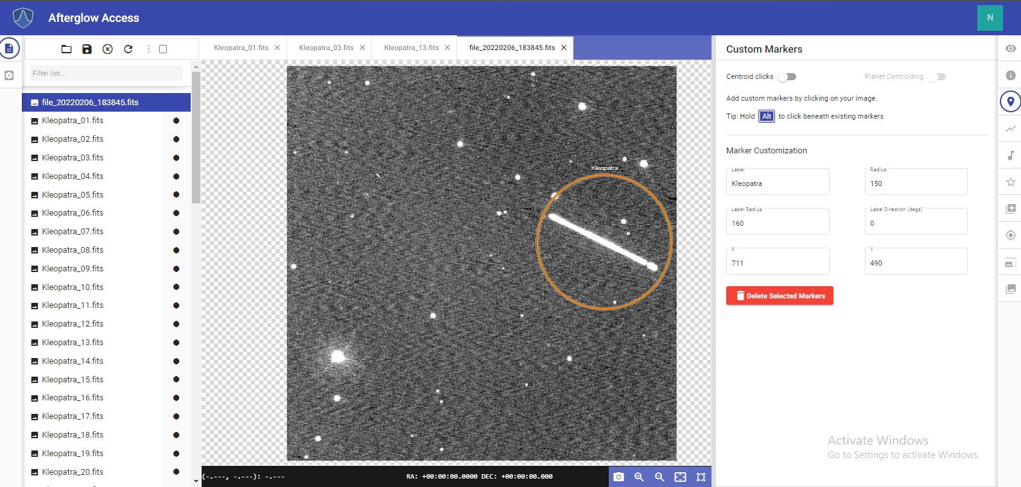
Caption: The stacked image of the Kleopatra files is shown in the entire AgA window. The file library list is open on the left side of the image. The Stacker tool panel is open on the right side of the image. The stacked image is located in the center and features several bright dots throughout the image. Moreover, near the top right of the image is a diagonal line of light, which is all of the stacked Kleopatra images. Around this diagonal line is an orange circular outline. This is a custom marker. Above this circle is the label “Kleopatra”.

Now, follow the steps to put a custom marker around a single image of Kleopatra.
- Select Kleopatra_01.fits in the file library list.
- Turn on the “Centroid Clicks” toggle button.
- Find the dot that is Kleopatra in the image, and click near the dot. A small circle should now surround Kleopatra.
- Double click on the circle. This will turn the marker orange, and the Marker Customization settings will become visible in the Custom Markers tool panel.
- Type “Kleopatra” in the Label box.
- Change the value of the Radius box so that the circle is larger than Kleopatra.
- Change the value in the Label Radius box so that the label Kleopatra is just outside the circle.

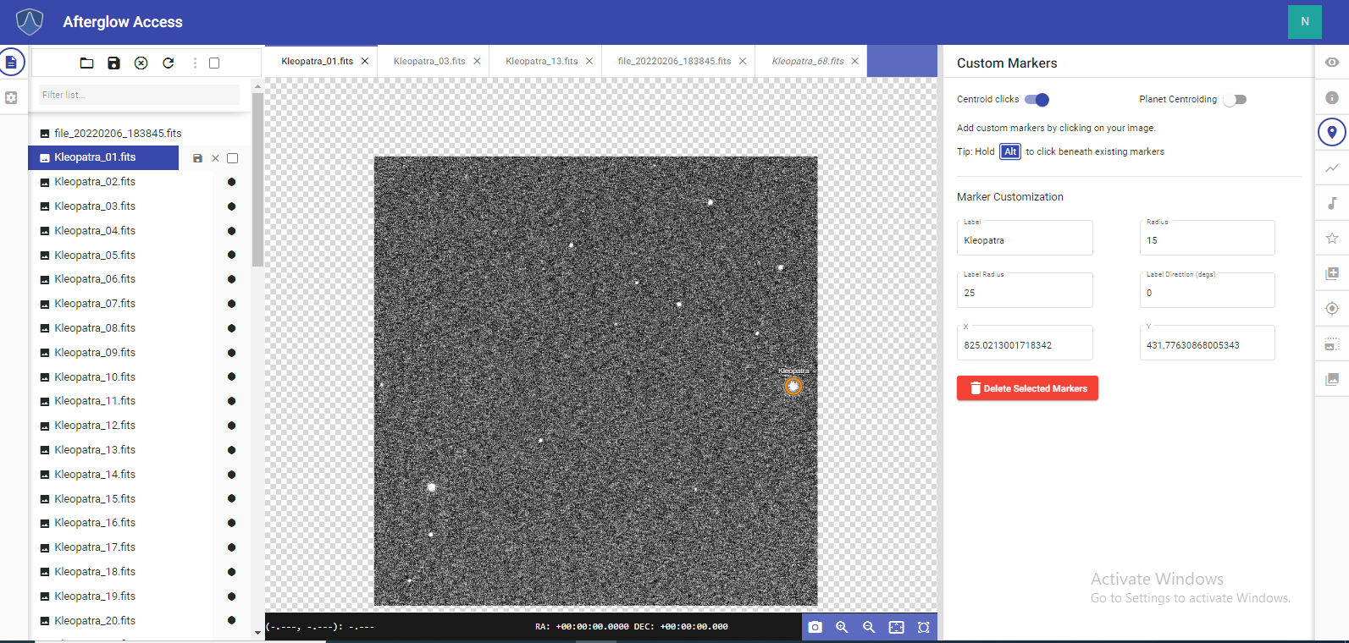

Caption: A picture of the night sky that contains the asteroid 216 Kleopatra is shown in the entire AgA window. The file library list is open on the left side of the image. The image of the night sky is located in the center, and it has several bright dots that appear like stars. One of these dots is Kleopatra. Around Kleopatra is an orange circular outline. This is a custom marker. Above the custom marker is the label “Kleopatra”.

15-f Back to Table of Contents

Plotter: Going Deeper

This is the first activity in a group of two Going Deeper activities that will utilize the Aligner, Stacker, File Info, Plotter, and Photometry tools. The activities will be divided according to the Plotter and Photometry sections. Together, these activities will answer the question, “How can astronomers determine the rotation rate of asteroids?”

Note: These sections will utilize the Aligner and Stacker tools. This section should only be completed after the user has completed the Aligner and Stacker Going Deeper activities, which explored the question, “How can astronomers discover or find asteroids?”

This activity will utilize part of the Kleopatra data set. In order to open the data set, follow the instructions below.
- Select the Open Files button.
- Select the Sample folder.
- Select the Solar System folder.
- Select the Asteroid 216 Kleopatra folder. There should be 68 images in the folder.
- Select the files Kleopatra_01.fits, Kleopatra_11.fits, Kleopatra_21.fits, Kleopatra_31.fits, Kleopatra_41.fits, Kleopatra_51.fits, and Kleopatra_61.fits.
- Click on the Open button.

Now, utilizing the directions found in the Aligner Going Deeper section, align this data set (referenced to Kleopatra_01.fits). If you need additional help, visit the Aligner section of this manual. After you have successfully aligned the images, stack the data set. If you need additional help with this step, visit either the Stacker section of this manual or the Stacker Going Deeper section.

Reference the image below to ensure that these steps were completed successfully. Note: In the Display Settings tool, the background level percentile was set to 89.2% and the saturation level percentile was set to 99.9%.

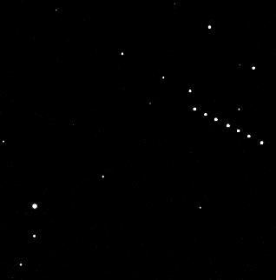
Caption: The stacked image of the Kleopatra files is shown above. There are several stars located throughout the image. Moreover, near the top right of the image is a diagonal line of dots. Each dot is asteroid Kleopatra, and the line of dots represents the movement of Kleopatra.

Now, open the Plotter tool. The Plotter tool can be used to measure how far an asteroid has moved from one image to another image. Select a point that is in line with the diagonal line of the Kleopatra images. Then select a second point such that the line passes through all of the points where Kleopatra is. A reference image with an appropriate line is shown below.
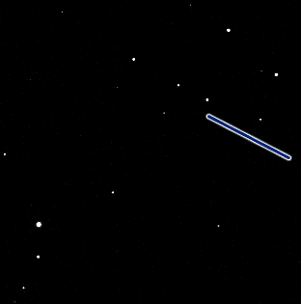
Caption: The stacked image of the Kleopatra files is shown above. The image has several stars throughout it. Moreover, near the top right of the image is a diagonal line that covers all of the Kleopatra images.

Now, there should be an x-y plot in the Plotter tool that has seven peaks. The x-axis location of each peak represents the pixel location of Kleopatra along the selected line. By looking at the pixel position of each point where Kleopatra is located, you can start to understand how fast Kleopatra is moving across the field of view. Hover your mouse over two peaks in the graph to find the pixel position of two of the Kleopatra images.

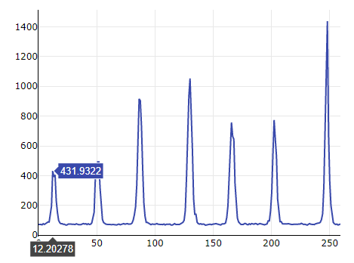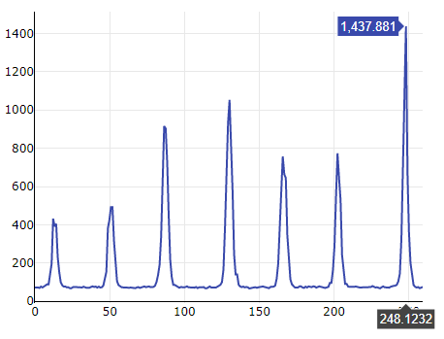

Caption: The x-y plot of the cross section including the Kleopatra images is shown above twice. Each time, the x-y plot has seven peaks. The x-axis represents the pixel location across the line and the y-axis represents the intensity of each pixel on the line. The x- and y-values for the center of the first peak are shown in the left image. The x- and y-values are (12.20278, 431.9322). The x- and y-values for the center of the last peak are shown in the right image. The x- and y-values are (248.1232, 1437.881).

The position of Kleopatra in the first image is 12.20278 and in the last image it is 248.1232. This imputes a total distance traveled of 235.92042 pixels. In order to see how fast Kleopatra is traveling, look at the center time value for each image in the File Info tool. Since this is for the first image and the last image, obtain this value for Kleopatra_01.fits and Kleopatra_61.fits.

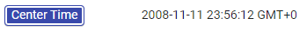

Kleopatra_01.fits was taken on November 11, 2008 at 11:56:12 pm. Kleopatra_61.fits was taken on November 12, 2008 at 4:35:01 am. Therefore, a total of 16,729 seconds passed between the images. Now, divide the number of pixels between the two images (235.92042) by the amount of time that passed between the two images (16,729 seconds). This yields a speed of roughly 0.014 pixels/second.

15-g Back to Table of Contents

Photometry: Going Deeper
This is the second activity in a group of two Going Deeper activities that will utilize the Aligner, Stacker, File Info, Plotter, and Photometry tools. The activities will be divided according to the Plotter and Photometry sections. Together, these activities will answer the question, “How can astronomers determine the rotation rate of asteroids?”

Note: If you have not completed the Plotter Going Deeper section, go to that activity and complete it now.

Since you have completed the Plotter Going Deeper activity, you should have a stacked image of seven Kleopatra images. Once that image is open in the display window, open the Photometry tool. Ensure that the “Centroid clicks”, “Show Sources From All Files”, “Auto-phot”, and “Source Markers” toggle buttons are all toggled on.
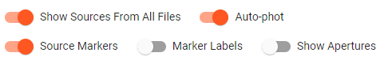

Note: Toggling on the “Show Apertures” toggle button may help you see exactly where you selected a source.
Now, select each point in the stacked image where Kleopatra appears. The first Kleopatra image that you should click is the lower right dot on the diagonal line. Then, work your way up through the line. The last image of Kleopatra that you should click is the top left dot. There should be a total of seven sources selected. Now that you have selected each of your sources, the magnitude of each point will be given in the table in the Photometry tool.
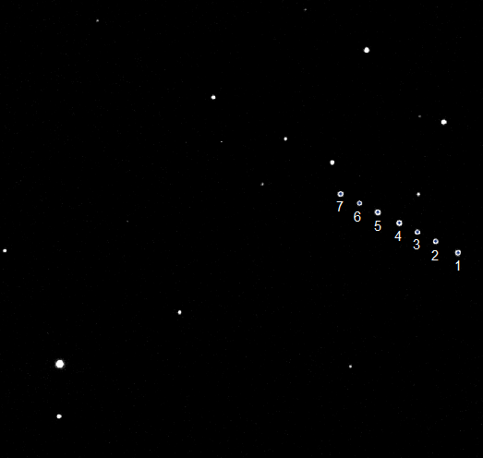
Caption: The stacked image of the Kleopatra files is shown above. There are several stars located throughout the image. Moreover, near the top right of the image is a diagonal line of dots. Each dot is asteroid Kleopatra, and the line of dots represents the movement of Kleopatra. Each of these dots is numbered either 1-7. The dot on the lower right is numbered 1, and the dot on the upper left is labeled 7. This represents the order that the dots should be clicked.
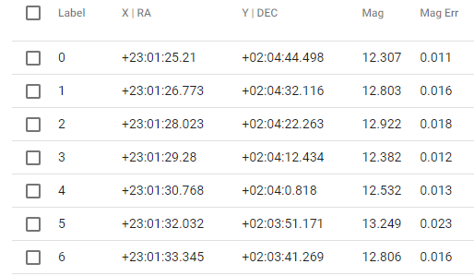
Caption: The data for each of the Kleopatra images in the stacked image is shown above. The sources are labeled 0-6, and the RA, DEC, magnitude, and magnitude error are given for each source.
Now, look at the magnitude of each point in the table. It changes with time. This suggests that the asteroid is not the same brightness over its entire surface and that it is rotating. You can estimate the rotation rate by looking at the time when the images were taken, the magnitude estimated at that time, and at the peaks or troughs in the light curve. Through all of this information, you can begin to understand the rotation rate of the asteroid.
In the images that were used, the images labeled 0 and 3 seem to be the brightest. This indicates that the brightest part of the asteroid is facing you. Source 0 has a magnitude of 12.307 and source 3 has a magnitude of 12.382.
Note: Brighter sources have a smaller magnitude.
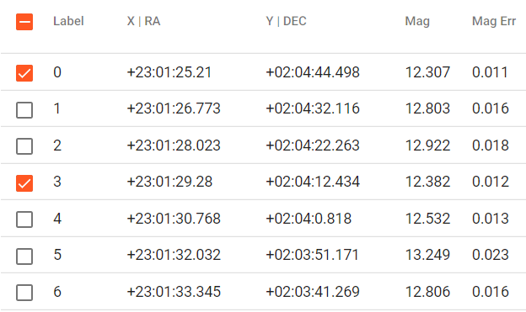
Caption: The data for each of the Kleopatra images in the stacked image is shown above. The sources are labeled 0-6, and the RA, DEC, magnitude, and magnitude error are given for each source. Source 0 and source 3 are selected.

Now, using the File Info tool, find the time when source 0 and source 3 were taken.
Kleopatra_01.fits (labeled 0 in the source list) was taken on November 11, 2008 at 11:56:12 pm.
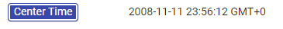
Kleopatra_31.fits (labeled 3 in the source list) was taken on November 12, 2008 at 2:17:07 am.
This means that the rotation rate of Kleopatra should be roughly 2 hours and 21 minutes since this is the time between two peaks in brightness. However, if you check the rotation rate of asteroid 216 Kleopatra online, this is not the rotation rate. The rotation rate of Kleopatra is approximately 5 hours, 23 minutes, and 24 seconds. You may be wondering why there is this discrepancy. However, if you look at the entire Kleopatra data set, the time from when Kleopatra_01.fits was taken to when Kleopatra_68.fits was taken is roughly 5 hours and 8 minutes. Therefore, the entire data set was taken in a shorter amount of time than the rotation rate of Kleopatra. If the data set was taken in a longer amount of time, then you could use this same method to find the actual rotation rate. The only reason that it appeared like we could find the rotation rate was because Kleopatra’s brightness varies in a way that there is more than one area on the asteroid that reflects the peak brightness.

15-h Back to Table of Contents

Pixel Operations: Going Deeper

This Going Deeper activity will use the “Add +” operand found in the Pixel Operations tool to modify an image of Saturn and Jupiter. The resulting image will be further fine-tuned using the Display Settings tool.

The Needed Files
First, open the saturn.fits file:
- Click on the Open Files button.
- Select the Sample folder.
- Select the Solar System folder.
- Select the saturn.fits file.

Next, open the jupiter.fits file:
- Click on the Open Files button.
- Select the Sample folder.
- Select the Solar System folder.
- Select the jupiter.fits file.

These files should now be in the file library list. Open the saturn.fits file, and ensure that it is displayed in the AgA window. Then, click on the Show Pixel Operations tab on the AgA toolbar. Ensure that you are using the Simple settings, and that Image is the selected mode.

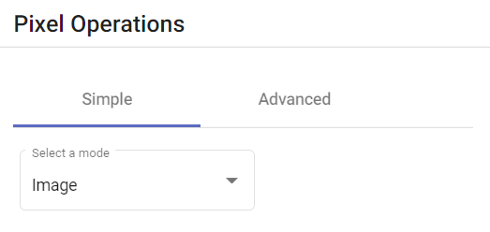

Since the image of Saturn is open in the display window, the saturn.fits file should be in the “Selected Image(s)” drop-down menu.

Next, select the “Add +” operand from the “Select an operand” drop-down menu. This selection dictates what operation will be performed between the images of Saturn and Jupiter.
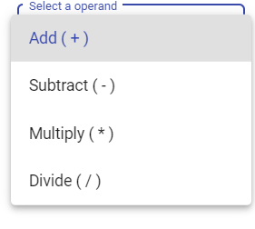
Now, select jupiter.fits in the “Select an Image” drop-down menu. This ensures that the image of Jupiter will be added to the image of Saturn.
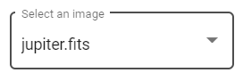

Before clicking on the Submit button, compare your settings to the screenshot below. This screenshot shows what each of the selections should be.
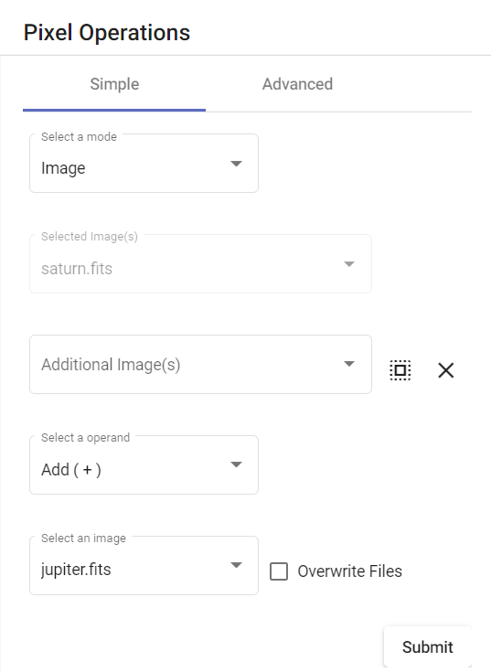

After this comparison, click on the Submit button. Since the Overwrite Files button was not selected, it should create a new file in the file library list. Open this file.

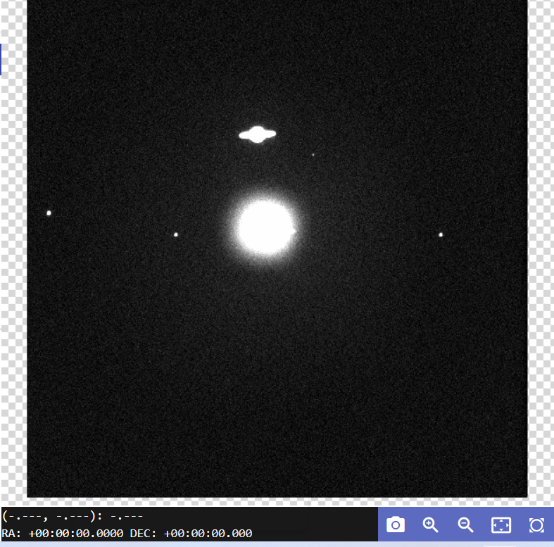
Caption: A new image was created as a result of the application of the pixel operand performed on the Jupiter and Saturn images, and it is shown above. The image shows Saturn, Jupiter, and three of Jupiter’s moons.

Now, click on the Show Display Settings tab on the AgA toolbar. Manipulating these settings allows the user to finetune the image’s features. The first suggested change is changing the Saturation Level Percentile to 99.5. The second suggested change is inverting the image by clicking on the “Inverted” toggle button. However, you are encouraged to explore the different ways that this image can be displayed.

Caption: A new image was created as a result of the application of the pixel operand performed on the Jupiter and Saturn images, and it is shown above. The image shows Saturn, Jupiter, and some of Jupiter’s moons. The image is shown using a gray color map. It is also inverted and zoomed in. Both planets are visible, as are two of Jupiter’s moons.

16 Back to Table of Contents

GLOSSARY

Afterglow Access (AgA): A complete browser-based astronomy image and data analysis software tool. The software is designed to work with screen readers and incorporates unique features that allow the user to experience images through sound. This makes astronomy more accessible to the blind and visually impaired.
Arcminutes: An angle measurement used in locating the position and size of astronomical objects. There are 60 arcminutes in a degree. Most astronomical objects appear much smaller than a degree in the sky, so arcminutes are more useful for measuring their size. The full moon is 30 arcminutes in the sky.
Arcseconds: An angle measurement used in locating the position and size of astronomical objects. There are 60 arcseconds in an arcminute, and 3600 arcseconds in a degree.
Autoscale: Automatically scaling an image
Batch Data: Multiple pieces of data
Blind and Visually Impaired (BVI): Any person who has a corrected visual acuity of less than either 20/40 or 20/60
Centroid Click: The use of an algorithm that shifts a marker to the point of the peak value, instead of the exact pixel clicked
Color Palette: A group of colors
Composite Image: An image made up of multiple images
Contrast: The degree of difference between the tones in an image
Cross-section: A graphic representation of the pixel intensity along a selected line segment
Declination: The name astronomers give to imaginary lines on the night sky similar to the lines of latitude on Earth. It is measured in degrees, minutes, and seconds.
.fits: An open standard defining a digital file format useful for the storage, transmission, and processing of data
Histogram: A graphical representation of data. Data are grouped into corresponding bins of intensity values on the x-axis. The y-axis then counts the number of pixels that fall into each brightness bin.
Intensity: Level of brightness in a pixel
Inverting: Flipping the colors in an image; e.g. black becomes white and white becomes black
.jpeg: A common file format used in digital photography, in which the photo is compressed but loses some of its quality. JPEG stands for “Joint Photographic Experts Group”
Kernel Filter: A filter applied to images for blurring, sharpening, and more. This is accomplished by taking a matrix, usually 3x3, and completing a specified mathematical function to each pixel in the matrix. The resulting value of this function is then applied to the pixel in the center of the matrix.
Normalization: A process through which pixels are assigned a color. The key parts of normalization are determining which pixel values are the darkest color, which pixel values are the lightest color, and how to assign the interim colors.
Orientation: The layout of the image, which is impacted by transformations. Examples of transformations include flipping, mirroring, and rotating.
Pixel: Smallest unit in a digital image
Planet Centroiding: The use of an algorithm that shifts a marker to the center of a planet, instead of the exact pixel clicked. It differs from regular centroiding because the algorithm is different since planets are not point sources.
Point Source: A localized point of light, such as a star
Radius: The length from the center of a custom marker circle to the outline of the marker, measured in pixels
Right Ascension: The name astronomers give to imaginary lines on the night sky similar to the lines of longitude on Earth. These lines run from pole to pole through the celestial equator. It is measured in hours, minutes, and seconds.
Saturation Level Percentile: A value that is related to the intensity assigned to the color white, or the lightest color in a colormap
Sonification: The use of sound to represent data that is typically presented visually
Toggle Button: A switch to turn functions on and off in AgA
Workbench Panel: The sections of AgA that either contain the tools or display the image
World Coordinate System (WCS): This system maps each pixel in an image to specific right ascension and declination coordinates in the night sky

x-y plot: A graphical display of data that shows one set of information on the x-axis and another set of information on the y-axis

17 Back to Table of Contents

APPENDIX

Shortcut Keys

The plus sign, “+,” is used to signify that two keys need to be pressed, not that you need to press the plus sign. While in some cases, the order in which the keys are pressed does not matter, sometimes the order does matter.

Workbench Shortcuts
Key | Description
shift + T | Open Theme Settings
? | Open Help Dialog
shift + F | Open File Manager
d | Display Tool
i | File Info Tool
m | Custom Markers Tool
shift + P | Plotting Tool
s | Sonification Tool
p | Photometry Tool
* | Pixel Operations
w | WCS Calibration Tool
a | Aligning Tool
shift + S | Stacking Tool
esc | Exit Expanded Panel View
, | Expand Workbench File Panel
. | Expand Workbench Image Panel
/ | Expand Workbench Tool Panel

Sonification Shortcuts
Key | Description
space | Play Sonification
ctrl + z | Undo Region Change
ctrl + y | Redo Region Change
left arrow | Navigation: Low Frequency
right arrow | Navigation: High Frequency
left arrow + right arrow | Navigation: Mid Frequency
down arrow | Navigation: Early
up arrow | Navigation: Late
down arrow + up arrow | Navigation: Middle
1 | Navigation: Low Frequency | Beginning
2 | Navigation: Mid Frequency | Beginning
3 | Navigation: High Frequency | Beginning
4 | Navigation: Low Frequency | Middle
5 | Navigation: Mid Frequency | Middle
6 | Navigation: High Frequency | Middle
7 | Navigation: Low Frequency | End
8 | Navigation: Mid Frequency | End
9 | Navigation: High Frequency | End
0 | Reset Sonification Region

Image Viewer Shortcuts
Key | Description
= | Zoom in
- | Zoom out
r | Reset zoom
z | Zoom to fit

Acknowledgements
Innovators Developing Accessible Tools for Astronomy (IDATA), officially known as Research Supporting Multisensory Engagement by Blind, Visually Impaired, and Sighted Students to Advance Integrated Learning of Astronomy and Computer Science, and the resulting curricular resources, Afterglow Access (AgA) software, and project research were made possible with support from the U.S. National Science Foundation’s STEM+C program (Award 1640131). IDATA institutional collaborators include AUI (Tim Spuck - Project PI, Yasmin Catricheo, and Joe Flannery), GLAS Education (Kate Meredith, Deb Kaelbli), Linder Research & Development Inc. (Tyler Linder), Logos Consulting Group (Bret Feranchak), TERC (Jim Hammerman – Project CoPI, Eric Hochberg, and Santiago Gasca), University of Nevada – Las Vegas (Andreas Stefik - Project CoPI, and Patrick Daleiden), University of North Carolina at Chapel Hill (Dan Reichart – Co-PI, Josh Haislip, and Vladimir Kouprianov, and Universidad Diego Portales (Erika Labbe, and Demian Aley Schkolnik). Individual consultants on the project include Kathy Gustavson and Alexandra Dean Grossi. IDATA Teacher collaborators in the U.S. include Amanda Allen, Jacqueline Barge, Holly Bensel, Neal Boys, Tim Fahlberg, Kristin Grender, David Lockett, Matthew McCutcheon, Caroline Odden, Michael Prokosch, Kara Rowbotham, Rick Sanchez, and Barbara Stachelski. IDATA Student collaborators in the U.S. include Evan Blad, Naleah Boys, Ellen Butler, Jayden Dimas, Riley Kappell, Joseph Murphy, Logan Ruby, Alex Scerba, Charlize Sentosa, Meg Sorensen, Remy Streichenberger, Trevor Warren, and others. IDATA Undergraduate Mentors include Tia Bertz, Katya Gozman, Chris Mathews, Kendall Mehling, Andrea Salazar, Ben Shafer, Alex Traub, and Sophia Vlahakis. Special thanks to the IDATA external advisors including Nic Bonne, Al Harper, Sue Ann Heatherly, Russ Laher, Luisa Rebull, Ed Summers and Kathryn Williamson.

